**Alterview Charts**

**User Guide**



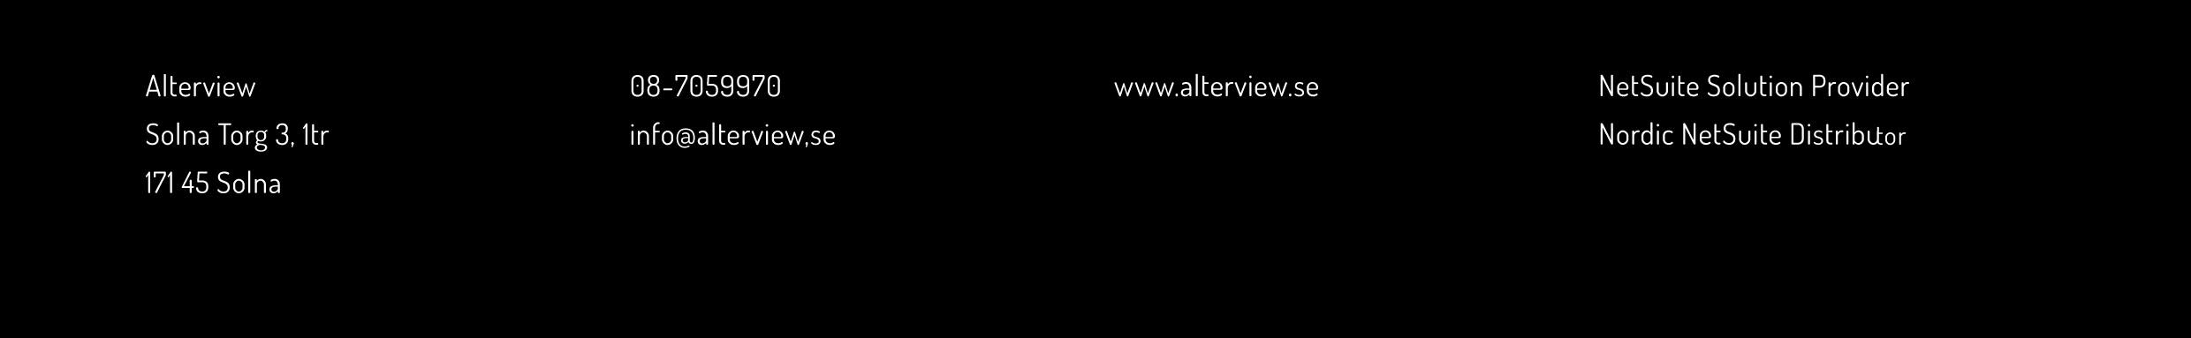

Copyright © 2018 Alterview Net Solutions AB. All Rights Reserved.

Table of Contents

Alterview Charts 3

Preparations 4

User Access 4

Available Types of Charts 5

Saved searches 6

Configuration 7

Additional Configuration 9

Chart Examples 11

Bar Chart 11

Layered Bar Chart 14

Multi Bar Chart 18

Donut Chart 22

Funnel Chart 25

Gauge Chart 28

Gauge Percentage Chart 32

Line Chart 35

Gantt Chart (Beta) 39

Pie Chart 42

Stacked Area Chart 45

Stacked Bar Chart 48

Data Grid Chart 54

Map with Bubbles 60

Map with Curved Lines 63

Move to Production 68

# Alterview Charts

Alterview Charts is a powerful tool to provide you with an instant graphical overview of your selected key performance indicators on your dashboard. Alterview Charts enables a more efficient way of working for you and your team, regardless business function. Use the pre-configured charts or configure your very own charts for your particular business figures, based on any standard or custom table in Netsuite.

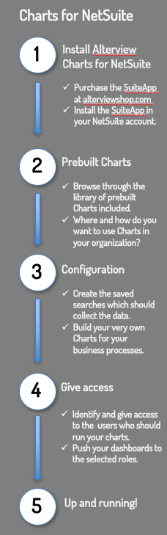

The process of getting started with Alterview Charts consists of a few simple steps.

Purchase the SuiteApp and install the bundle in your NetSuite account.

Use some of the many pre-configured charts simply by displaying them in a custom portlet on your dashboard.

OR

Configure your very own charts by creating a saved search to collect accurate data, select type of chart/graph and define how to display your data in the chart/graph.

Finish the process by giving access to your charts for selected users and display them in a custom portlet on your dashboard.

**Important**: please be aware that charts based on searches containing high volume of data may suddenly return a timeout as well as functions that generate excessive level of activity may trigger metering of script execution as referenced in the NetSuite Main Terms of Service

# Preparations

Before starting with the configuration of the chart in your NetSuite account it is a good idea to design a draft of the layout on paper and decide what data to include.

You should mainly consider:

* Which data will be presented in the chart (this determines what the search will be based on).
* Which type of chart/graph is best suited for the data you wish to present.

This User Guide provides general guidelines for configuring a new chart as well as a step-by-step configuration guide for each available chart type. The data presented in these examples are included in the bundle as prebuilt charts and can be used as inspiration and guidance when setting up your own charts, to display KPI-figures for your business needs.

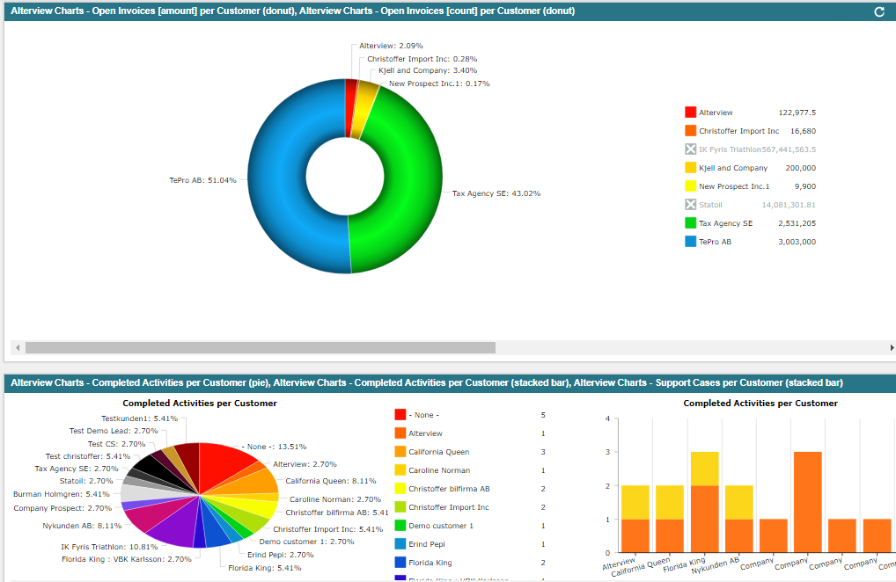

# User Access

The Alterview Charts Administrator role included with the bundle has a Test Area where all pre-configured Charts, as well as your customized charts, can be previewed before moved to production. In order to preview Charts in the test area an Alterview Charts User access is needed. Navigate to Administration 🡪 Alterview Chart Users to create a new Alterview Charts Users record for the user. Once this is done, the charts will be available to preview in the test area.



# Available Types of Charts



There are currently fourteen types of charts to select from:

* Bar Chart
* [Data Grid](#Data Grid Chart)
* Donut Chart
* Funnel Chart
* Gauge Chart
* Gauge Percentage Chart
* Stacked Bar Chart
* Line Chart
* [Map with bubbles](#Map with bubbles)
* [Map with Lines](#Map with Curved Lines)
* Multi Bar Chart
* Pie Chart
* Stacked Area Chart
* Layered Bar Chart

Step-by-step instructions are provided for each chart type in this user guide (please click on a chart type name to jump straight to the instructions for that particular chart type).

Regardless of the type of chart selected, all charts uses saved searches to collect accurate data to display.

# 

# Saved searches

Navigate to Administration 🡪 Alterview Chart Setup 🡪 Saved Searches 🡪 New   
(using the role ”Alterview Charts Administrator”)

1. **General information**   
   Select the record which the search will be based on. Give the search a name and make sure to make it a public search.

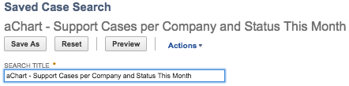

1. **Criteria**   
   Define any criteria to apply on the search in order to only include relevant posts (for example date limitations, type of transactions or a specific status).
2. **Results**   
   Select which data to include in the chart in the Results-tab. It is possible to include fields from the base record (the record you base your search on), from child records and formula fields. In most cases a Summary type is selected, to display aggregations of the selected data.   
     
   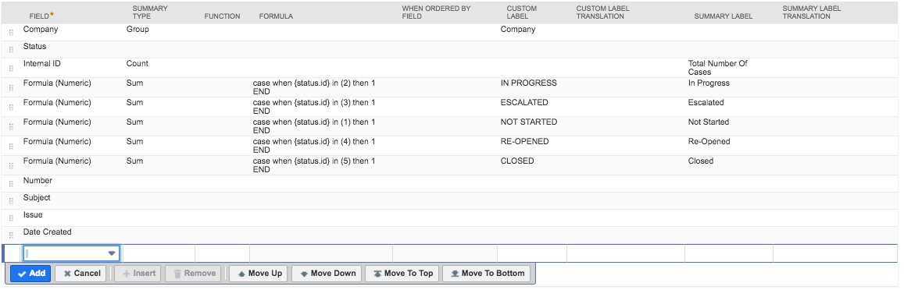
3. **Custom Labels**   
   Define Custom Labels for the fields in the Results-tab in in order to display the data in the chart. Please note that a Summary label is needed for fields with a selected Summary type.
4. **Save**  
   Finish by saving the search, and again, make sure to make it public.

# Configuration

Setting up a new chart is done in two steps – first a new Chart Configuration record is created (selecting type of chart etc.) and then a new Chart Search record is created (connecting the selected chart with the saved search).

1. **Chart Configuration Record**   
   *Navigate to Administration 🡪 Alterview Chart Setup 🡪 Charts 🡪 New*  
     
   Start by selecting type of chart/graph by clicking on one of the chart types images – this will display all fields valid for that particular chart type.   
     
     
     
   Give the chart a name, enter information regarding style/layout (optional) and save the record. (Please refer to *Chart Examples* for configuration details for each chart type)  
     
   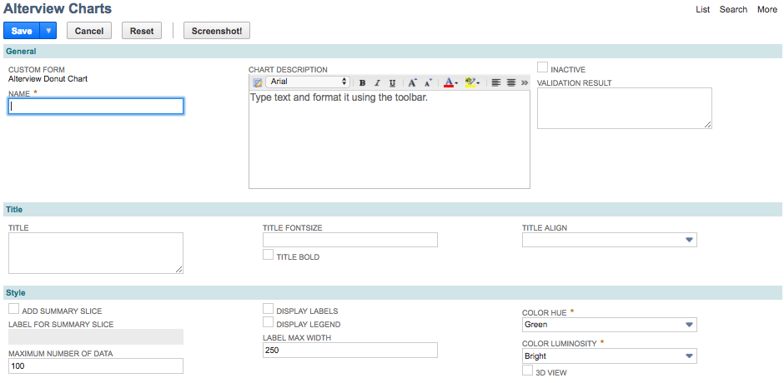  
     
   Once the Chart Configuration record has been saved one or several Chart Search records should be created as sub-records to the Configuration, connecting the saved search/searches to the chart.
2. **Chart Search Record**   
   From the Chart Configuration record one or several Chart Search records should be created, to connect the saved search/searches to the chart. This is done by clicking on the button *New Alterview Charts Search*.  
   1. In the Alterview Chart Search record, start by selecting which search to connect to the chart.
   2. In the fields *Value Field* and *Title Field*, enter the label (custom or summary label) from the saved search corresponding to the data you wish to display in the chart. Make sure to match the label from the saved search exactly (case sensitive).   
        
      Typically the *Value Field* will be displayed on the Y-axis and the *Title Field* will be displayed on the X-axis. (Please refer to the section [*Chart Examples*](#Chart Examples)for detailed setup instructions for each chart type).

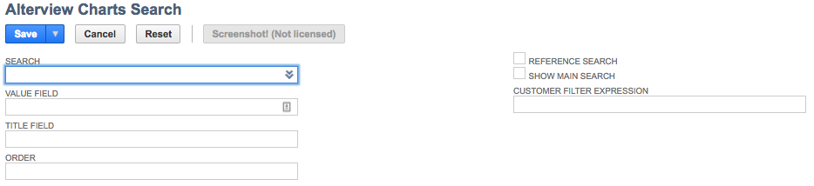

1. **Multiple searches in one chart**  
   Alterview Charts enables you to connect several saved searches or the same search multiple times to one chart, making it possible to display data from multiple sources in you chart.   
     
   Typically the Title Field will display the data which the saved searches have in common.

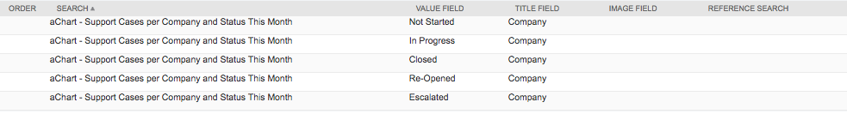

# Additional Configuration

When working with Alterview Charts there are a couple of common functions available which are optional to configure.

1. **Additional Filters** (*only valid when using Alterview Charts together with Alterview Navigator*)  
     
   The Additional Filters is a functionality used together with Alterview Navigator. The Alterview Navigator is a portlet where the user can define a group of entity fields, which can be used in almost all searches to narrow down the result for the current user. In many cases the company does not allow access to the record type "employee", this can be solved with the function Additional filters.  
     
   Additional filters will also solve the issue of saved searches time out, which can occur when creating searches for large tables or when adding a dynamic filter from the current user. Additional filters will retrieve the entity values from the current user and add that filter as a static filter, which is extremly fast.  
     
   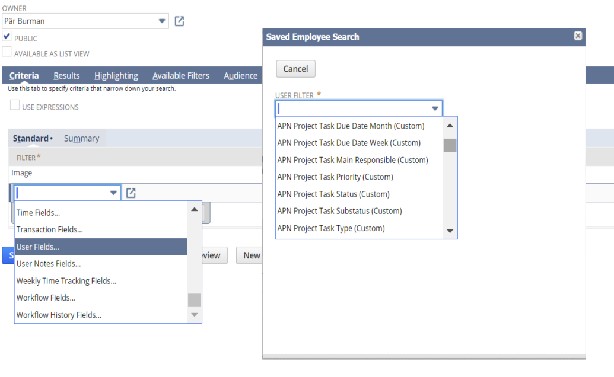  
   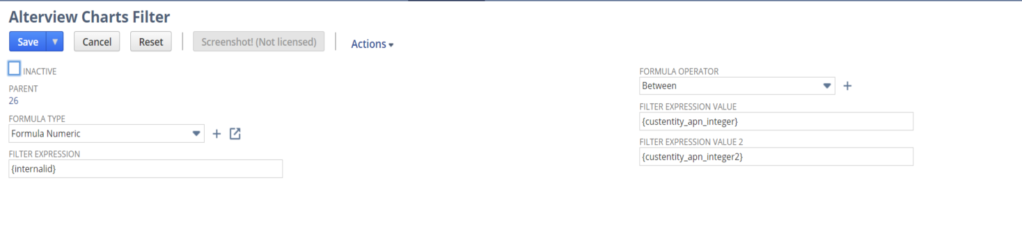
2. **Search Summary Field Type**  
   When using Gauge and Gauge Percentage Charts, the searches can produce more than one row even if the Gauge itself need only one result from each search. In this scenario, you need to inform Alterview Charts how to summarize the Value Field that occurs on several rows.   
     
   In the case below the search for Gauge Max produces several rows and the result should be the sum all rows. Therefore, when linking your search to the chart (i.e. creating an Alterview Chart Search record) the field Value Field Summary Type should be set to **Sum.**

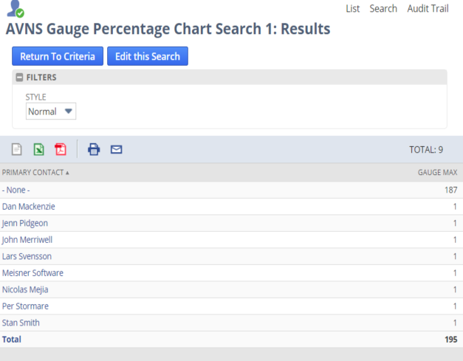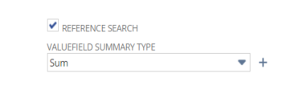

1. **Chart Title using Alterview Navigator**(*only valid when using Alterview Charts together with Alterview Navigator*)  
   When using Alterview Charts together with Alterview Navigator it is possible to use any of the custentity fields that are defined in Alterview Navigator. The syntax is ${id of entityfield}. Only fields with ID starting with "custentity_apn_" can be used.  
     
   Example:  
   “${custentity_apn_projecttaskassigned}: Between ${custentity_apn_fromdate} - ${custentity_apn_todate}” would be translated to "Marc Evans: Between 2017-10-12 - 2017-11-12".

# Chart Examples

The configuration of the Alterview Chart record will decide the layout of the chart. Each chart type has specific functionalities and layout options. Please refer to the description of your selected chart type for configuration details.

#### Bar Chart

The Bar chart is used to compare values for several units to each other, for example sales per employee, sales per month etc.



1. **Configure the search**

*Number of searches: 1*

Make sure the saved search is public and to include a Custom Label for the fields which will be displayed in the chart.

The search must include a minimum of 2 columns:

1. Name (of the item/unit to be displayed in the chart)
2. Value (of the item/unit to be displayed in the chart

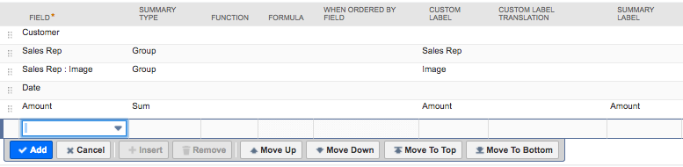

*In this DEMO Sales search: Name = Sales Rep & Value = Amount*

For Bar charts it is also possible to include an image of the item/unit, by including an image field in the saved search. Make sure to give the image field a Custom Label.

1. **Create the chart record**

After the search is created and tested a new Alterview Charts record must be created.

Navigate to Administration 🡪 Alterview Charts Setup 🡪 Charts 🡪 New to create a new Alterview Charts record. Enter information in the fields as described below.

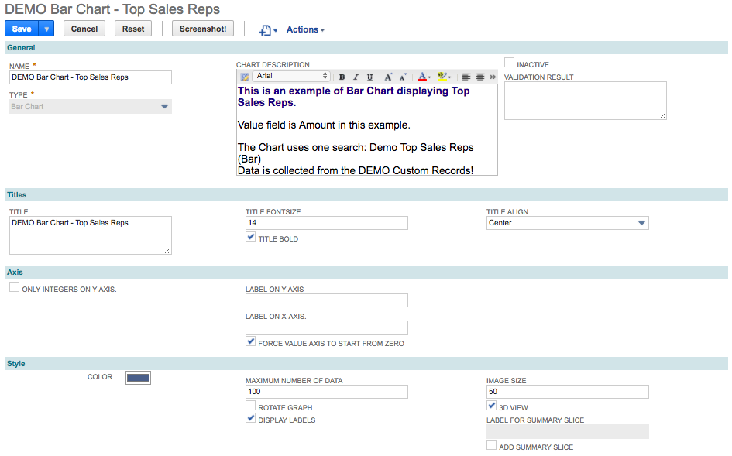

|  |  |
| --- | --- |
| Field Name | Description |
| Name | The name should be descriptive and give the user a hint of what is displayed in the dashboard portlet. |
| Chart Description | An extra field where you could add extra information about the chart. The description can be accessed from the dashboard portlet by hovering over the “?” icon in the upper left corner of the chart. |
| Title | The chart title will be displayed centered above the graph. When combining Alterview Charts with Alterview Navigator extra info is avaliable (please refer to Chart Title Using Alterview Navigator). |
| Title Font Size | Font size of chart title in pixels. |
| Title Bold | Mark checkbox to make the chart title bold. |
| Title Align | Select the alignment of the chart title. |
| Only Integers on Y-axis | Mark the checkbox to only display integers on Y-axis. |
| Label on Y-axis | A static label which will be centered vertically in the chart. |
| Label on X-axis | A static label which will be centered horizontally in the chart. |
| Force value to start from zero | Mark the checkbox to force the value axis to start from zero. |
| Color | Select the colors of the bars in the chart. |
| Maximum number of bars | Optionally set a maximum number of bars to display in the chart. Recommended if your saved search returns too many results. Too much data in a chart will make it cluttered and is not recommended. |
| Rotate Graph | Rotates the graph 90 degrees clockwise. |
| Display Labels | Mark the checkbox to display the name of the labels below each bar. |
| Image size | Image size in pixel. |
| 3D-view | Mark the checkbox for 3D-effect. |

1. **Link the search to your chart record**

From the Alterview Chart record, click on the button *New Alterview Chart Serarch* to create a new Alterview Chart Search child record to you chart. Enter information in the fields as described below.

Please note that *Alterview Charts Filter* is only needed when using *Alterview Navigator* to filter the chart.

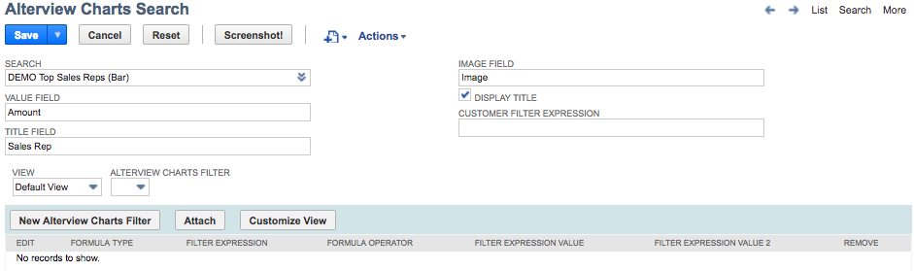

|  |  |
| --- | --- |
| Field | Description |
| Search | The name of the search (make sure the search is public). |
| Value Field | The Custom Label for the column that holds the relevant value for this search. |
| Title Field | The Custom Label for the column that holds the relevant title for this search. |
| Image Field | The Custom Label for the column that holds the image. Make sure that the image can be used by the audience that will use the Chart (permissions).  (Note that the url could be a relative URL, for example: /core/media/media.nl?id=1284&c=TSTDRV941030&h=6b4a028a1a10d1b7f99a). |
| Display title | Mark the checkbox to display a title on top of each bar. |
| Alterview Charts Filter | Only needed when using *Alterview Navigator* to filter the chart (please refer to Additional Filters). |

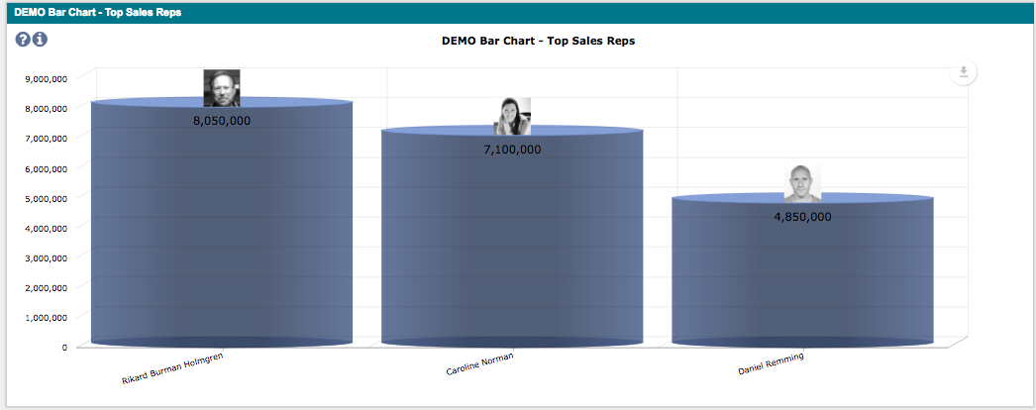

#### Layered Bar Chart

A Layered bar chart presents categorical data with rectangular bars with heights proportional to the values that they represent. With layered bars it is possible to compare data between different periods or calculated result versus actual result for each bar and display the result in layers.



1. **Configure the search**

*Number of searches: 1 or more*

Make sure the searches are public and to include a Custom Label for the fields which will be displayed in the chart. If it's a summary search the Summary label must also be defined.

The search must include a minimum of 2 columns:

1. Name (of the item/unit to be displayed in the chart)
2. Value (of the item/unit to be displayed in the chart)

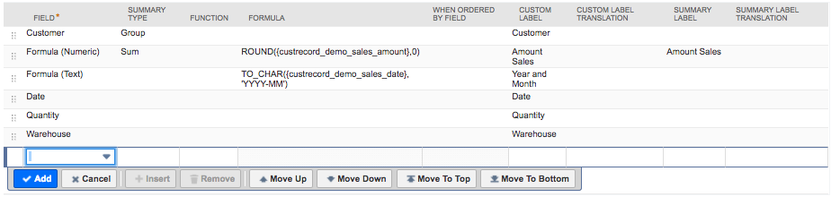

*In this DEMO Sales search: Name = Company, Value = Amount Sales*

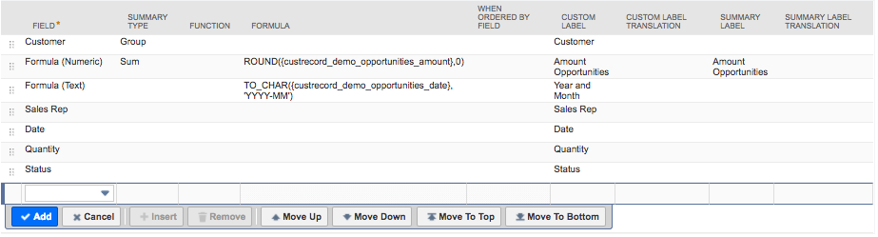

*In this DEMO Opportunities search: Name = Company, Value = Amount Opportunities*

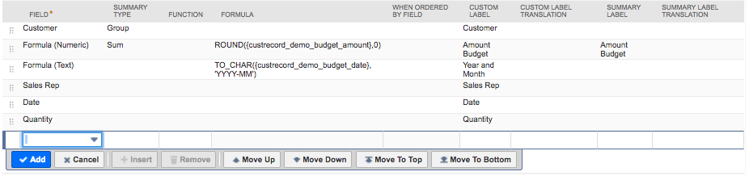

*In this DEMO Budget search: Name = Company, Value = Amount Budget*

1. **Create the chart record**

After the search is created and tested a new Alterview Charts record must be created.

Navigate to Administration 🡪 Alterview Charts Setup 🡪 Charts 🡪 New to create a new Alterview Charts record. Enter information in the fields as described below.

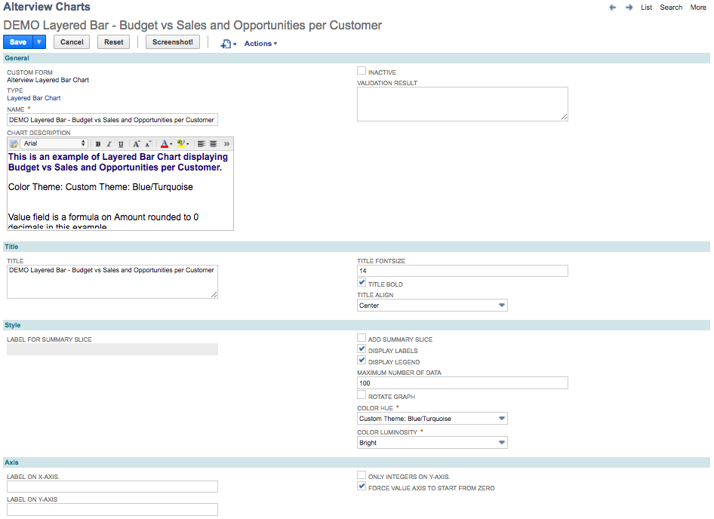

|  |  |  |
| --- | --- | --- |
| Field Name | | Description |
| Name | | The name should be descriptive and give the user a hint of what is displayed in the dashboard portlet. |
| Chart Description | | An extra field where you could add extra information about the chart. The description can be accessed from the dashboard portlet by hovering over the “?” icon in the upper left corner of the chart. |
| Title | | The chart title will be displayed centered above the graph. When combining Alterview Charts with Alterview Navigator extra info is avaliable (please refer to Chart Title Using Alterview Navigator). |
| Title Font Size | | Font size of chart title in pixels. |
| Title Bold | | Mark checkbox to make the chart title bold. |
| Title Align | | Select the alignment of the chart title. |
| Display Labels | | Mark the checkbox to display the name of the labels below each bar. |
| Display Legend | | Mark the checkbox to display the legend for each bar to the right of the chart. |
| Maximum number of data | | Optionally set a maximum number of bars to display in the chart. Recommended if your saved search returns too many results. Too much data in a chart will make it cluttered and is not recommended. |
| Rotate Graph | | Rotates the graph 90 degrees clockwise. |
| Color hue | | The color hue of the bars. |
| Color Luminosity | | The color luminosity of the bars. |
| Label on X-axis | A static label which will be centered horizontally in the chart. | |
| Label on Y-axis | A static label which will be centered vertically in the chart. | |
| Only integers on Y-axis | | Mark the checkbox to only show integers on Y-axis. |
| Force value axis to start from zero | | Mark the checkbox to force the value axis to start from zero. |

1. **Link the search to your chart record**

For the Layered Bar chart it is recommended to include at least two *Alterview Chart Search* records. It is possible to use the same saved search for every Alterview Chart Search record or to use different saved searches for each Alterview Chart Search record.  
  
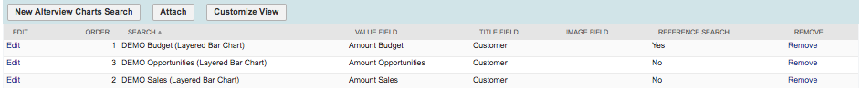  
*In this example three different saved search has been to display data in the chart.*

From the Alterview Chart record, click on the button *New Alterview Chart Serarch* to create a new Alterview Chart Search child record to you chart. Enter information in the fields as described below. To display several values in one layered bar, the values are grouped into the same bar by using the same Title field for each Alterview Charts Search record.

Please note that *Alterview Charts Filter* is only needed when using *Alterview Navigator* to filter the chart.   
  
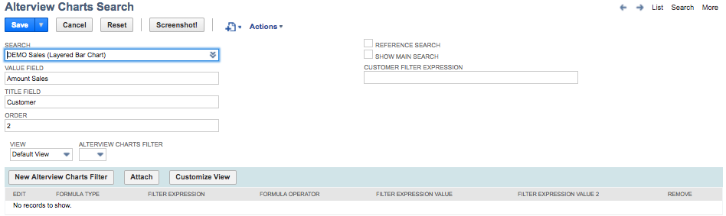

|  |  |
| --- | --- |
| Field | Description |
| Search | The name of the search (make sure the search is public). |
| Value Field | The Custom Label for the column that holds the relevant value for this search. |
| Title Field | The Custom Label for the column that holds the relevant title for this search. |
| Order | Each saved search will be layered on top of each other. The order field will control both legend and the order of how the result is layered. |
| Reference Search | When a maximum number of data has been set for the chart, and the different searches returns different number of results, one of the searches must be set as reference search to define which results to show and in which order. |
| Show main search | If both **Reference Search** and **Show main search** is checked, this search will not show up in the chart and only work as a reference for the other searches. |
| Customer Filter Expression | If the chart is going to be used in a customer dashboard or on a tab on the customer record, set the expression that will be used to filtering out the customer.  Example 1:[customermain.internalidnumber,equalto,{id}]  Example 2:[entityid,anyof,{id}]  Example 3:[formulanumeric: {internalid},equalto,{id}]  Where the {id} is the internalid of current customer the {id} is substituted by the application at runtime. |
| Alterview Charts Filter | Only needed when using *Alterview Navigator* to filter the chart (please refer to Additional Filters). |

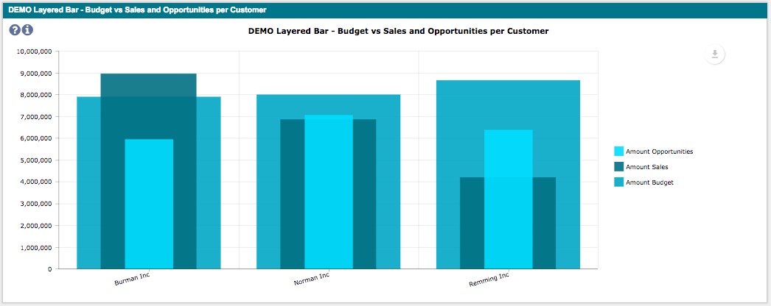

#### Multi Bar Chart

In a multi bar chart, two or more sets of inter related data are represented, with the different sets layered in a 3D view. To make the chart readable the order of the different sets is important, to make sure the bars do not hide one another.



1. **Configure the search**

*Number of searches: 1 or more*

Make sure the searches are public and to include a Custom Label for the fields which will be displayed in the chart. If it's a summary search the Summary label must also be defined.

The search must include a minimum of 2 columns:

1. Name (of the item/unit to be displayed in the chart)
2. Value (of the item/unit to be displayed in the chart)

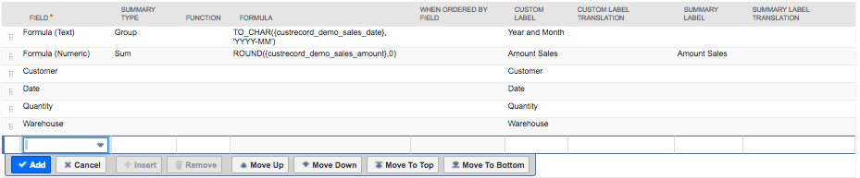

*In this DEMO Sales search: Name = Company, Value = Amount Sales*

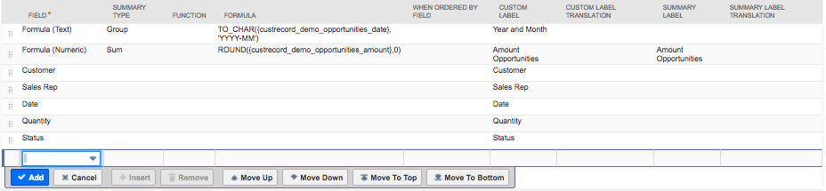

*In this DEMO Opportunities search: Name = Company, Value = Amount Opportunities*

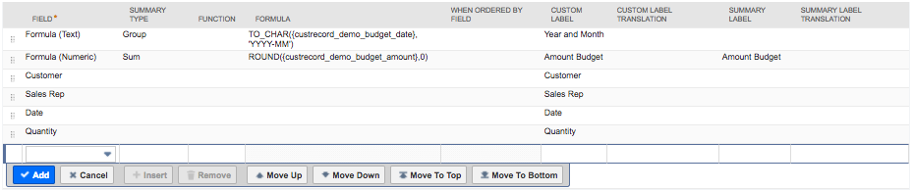

*In this DEMO Budget search: Name = Company, Value = Amount Budget*

1. **Create the chart record**

After the search is created and tested a new Alterview Charts record must be created.

Navigate to Administration 🡪 Alterview Charts Setup 🡪 Charts 🡪 New to create a new Alterview Charts record. Enter information in the fields as described below.

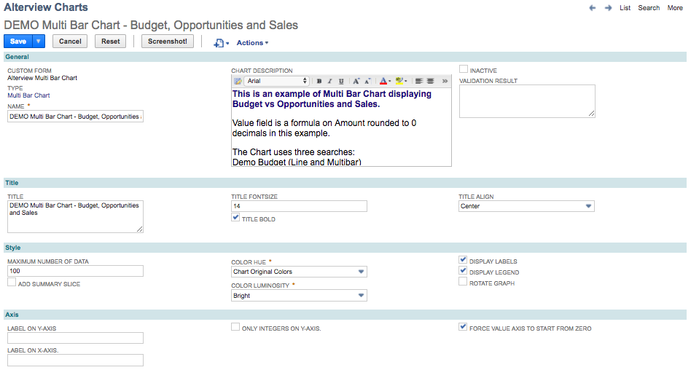

|  |  |  |
| --- | --- | --- |
| Field Name | | Description |
| Name | | The name should be descriptive and give the user a hint of what is displayed in the dashboard portlet. |
| Chart Description | | An extra field where you could add extra information about the chart. The description can be accessed from the dashboard portlet by hovering over the “?” icon in the upper left corner of the chart. |
| Title | | The chart title will be displayed centered above the graph. When combining Alterview Charts with Alterview Navigator extra info is avaliable (please refer to Chart Title Using Alterview Navigator). |
| Title Font Size | | Font size of chart title in pixels. |
| Title Bold | | Mark checkbox to make the chart title bold. |
| Title Align | | Select the alignment of the chart title. |
| Maximum number of data | | Optionally set a maximum number of bars to display in the chart. Recommended if your saved search returns too many results. Too much data in a chart will make it cluttered and is not recommended. |
| Color hue | | The color hue of the bars. |
| Color Luminosity | | The color luminosity of the bars. |
| Display Labels | | Mark the checkbox to display the name of the labels below each bar. |
| Display Legend | | Mark the checkbox to display the legend for each bar to the right of the chart. |
| Rotate Graph | | Rotates the graph 90 degrees clockwise. |
| Label on X-axis | A static label which will be centered horizontally in the chart. | |
| Label on Y-axis | A static label which will be centered vertically in the chart. | |
| Only integers on Y-axis | | Mark the checkbox to only show integers on Y-axis. |
| Force value axis to start from zero | | Mark the checkbox to force the value axis to start from zero. |

1. **Link the search to your chart record**

For the Multi Bar chart it is recommended to include at least two *Alterview Chart Search* records. It is possible to use the same saved search for every Alterview Chart Search record or to use different saved searches for each Alterview Chart Search record.

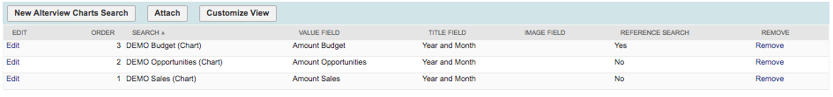  
*In this example three different saved search has been selected to display data in the chart.*

From the Alterview Chart record, click on the button *New Alterview Chart Serarch* to create a new Alterview Chart Search child record to you chart. Enter information in the fields as described below. To display several values in one layered bar, the values are grouped into the same bar by using the same Title field for each Alterview Charts Search record.

Please note that *Alterview Charts Filter* is only needed when using *Alterview Navigator* to filter the chart.

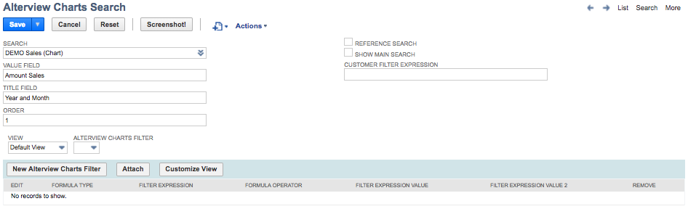

|  |  |
| --- | --- |
| Field | Description |
| Search | The name of the search (make sure the search is public). |
| Value Field | The Custom Label for the column that holds the relevant value for this search. |
| Title Field | The Custom Label for the column that holds the title. |
| Order | Each saved search will be layered on top of each other. The order field will control both legend and the order of how the result is layered. |
| Reference Search | When a maximum number of data has been set for the chart, and the different searches returns different number of results, one of the searches must be set as reference search to define which results to show and in which order. |
| Show main search | If both **Reference Search** and **Show main search** is checked, this search will not show up in the chart and only work as a reference for the other searches. |
| Customer Filter Expression | If the chart is going to be used in a customer dashboard or on a tab on the customer record, set the expression that will be used to filtering out the customer.  Example 1:[customermain.internalidnumber,equalto,{id}]  Example 2:[entityid,anyof,{id}]  Example 3:[formulanumeric: {internalid},equalto,{id}]  Where the {id} is the internalid of current customer the {id} is substituted by the application at runtime. |
| Alterview Charts Filter | Only needed when using *Alterview Navigator* to filter the chart (please refer to Additional Filters). |

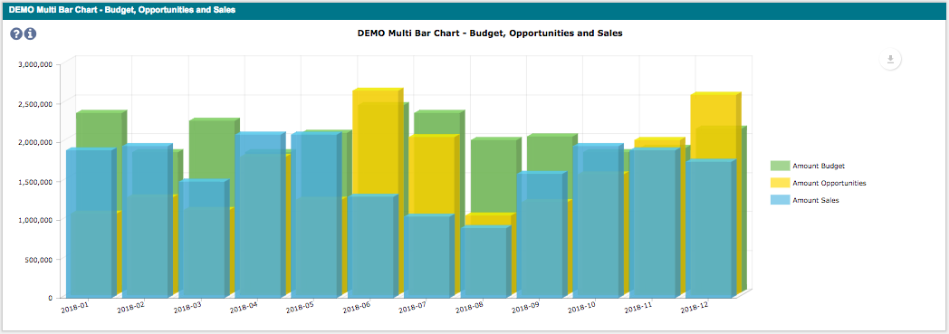

#### Donut Chart

Donut charts is a good choice when visualizing for example market share per company.



1. **Configure the search**

*Number of searches: 1*

Make sure the saved search is public and to include a Custom Label for the fields which will be displayed in the chart. If it's a summary search the Summary label must also be defined.

The search must include a minimum of 2 columns:

1. Name (of the item/unit to be displayed in the chart)
2. Value (of the item/unit to be displayed in the chart

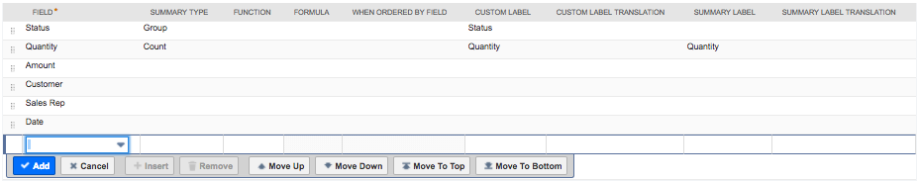

*In this DEMO Opportunities search: Name = Status, Value = Quantity*

1. **Create the chart record**

After the search is created and tested a new Alterview Charts record must be created.

Navigate to Administration 🡪 Alterview Charts Setup 🡪 Charts 🡪 New to create a new Alterview Charts record. Enter information in the fields as described below.

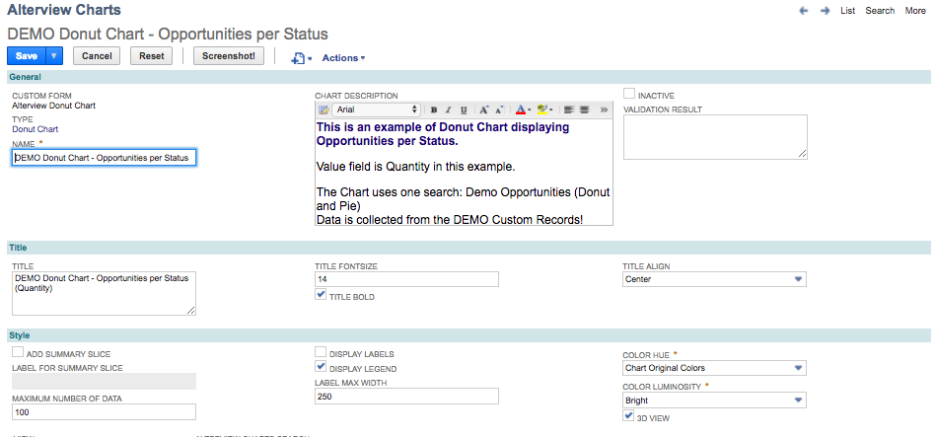

|  |  |
| --- | --- |
| Field Name | Description |
| Name | The name should be descriptive and give the user a hint of what is displayed in the dashboard portlet. |
| Chart Description | An extra field where you could add extra information about the chart. The description can be accessed from the dashboard portlet by hovering over the “?” icon in the upper left corner of the chart. |
| Title | The chart title will be displayed centered above the graph. When combining Alterview Charts with Alterview Navigator extra info is avaliable (please refer to Chart Title Using Alterview Navigator). |
| Title Font Size | Font size of chart title in pixels. |
| Title Bold | Mark checkbox to make the chart title bold. |
| Title Align | Select the alignment of the chart title. |
| Add Summary Slice | Mark the checkbox to add a summary slice. When the number of result rows in the saved search exceeds the "Maximum number of data" set in the Alterview Charts record an extra slice will be added, which holds the aggregated value of the remaining result rows. |
| Label for summary slice | The name of the summary slice which holds the aggregated value of the remaining result rows. |
| Maximum number of data | Optionally set a maximum number of data to display in the chart. Recommended if your saved search returns too many results. Too much data in a chart will make it cluttered and is not recommended. |
| Display Labels | Mark the checkbox to display the name of the labels for each slice. |
| Display legend | Mark the checkbox to display the legend for each bar to the right of the chart. |
| Label max width | The label width is the width in pixels for both the legend and the labels. If the width is too small, all labels will be wrapped character per character and not word by word. |
| Color hue | The color hue of the slices. |
| Color Luminosity | The color luminosity of the slices. |
| 3D-view | Mark the checkbox for 3D-effect. |

1. **Link the search to your chart record**

From the Alterview Chart record, click on the button *New Alterview Chart Serarch* to create a new Alterview Chart Search child record to you chart. Enter information in the fields as described below.

Please note that *Alterview Charts Filter* is only needed when using *Alterview Navigator* to filter the chart.

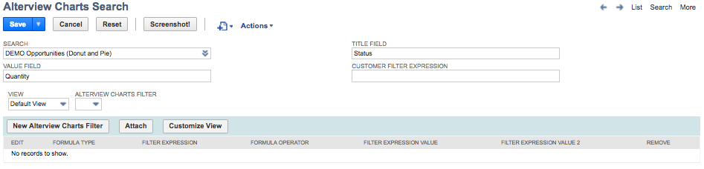

|  |  |
| --- | --- |
| Field | Description |
| Search | The name of the search (make sure the search is public). |
| Value Field | The Custom Label for the column that holds the relevant value for this search. |
| Title Field | The Custom Label for the column that holds the title. |
| Customer Filter Expression | If the chart is going to be used in a customer dashboard or on a tab on the customer record, set the expression that will be used to filtering out the customer.  Example 1:[customermain.internalidnumber,equalto,{id}]  Example 2:[entityid,anyof,{id}]  Example 3:[formulanumeric: {internalid},equalto,{id}]  Where the {id} is the internalid of current customer the {id} is substituted by the application at runtime. |
| Alterview Charts Filter | Only needed when using *Alterview Navigator* to filter the chart (please refer to Additional Filters). |

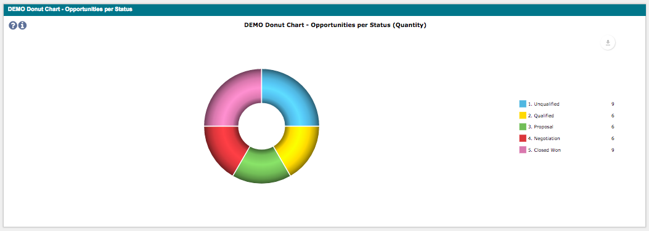

#### Funnel Chart

Funnel charts is a great chart to use to represent stages in a sales process and show the amount of potential revenue for each stage. This type of chart can also be useful in identifying potential problem areas in an organization’s sales processes.



1. **Configure the search**

*Number of searches: 1*

Make sure the saved search is public and to include a Custom Label for the fields which will be displayed in the chart. If it's a summary search the Summary label must also be defined.

The search must include a minimum of 2 columns:

1. Name (of the item/unit to be displayed in the chart)
2. Value (of the item/unit to be displayed in the chart

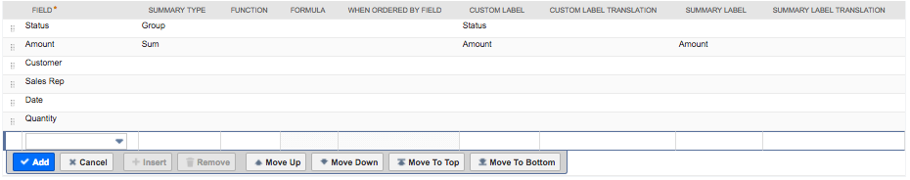

*In this DEMO Opportunities search: Name = Status, Value = Amount*

1. **Create the chart record**

After the search is created and tested a new Alterview Charts record must be created.

Navigate to Administration 🡪 Alterview Charts Setup 🡪 Charts 🡪 New to create a new Alterview Charts record. Enter information in the fields as described below.

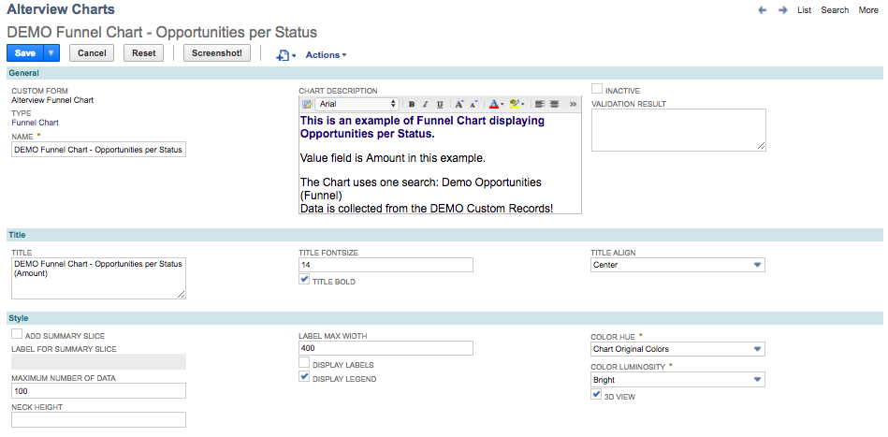

|  |  |
| --- | --- |
| Field | Description |
| Name | The name should be descriptive and give the user a hint of what is displayed in the dashboard portlet. |
| Description | An extra field where you could add extra information about the chart. The description can be accessed from the dashboard portlet by hovering over the “?” icon in the upper left corner of the chart. |
| Title | The chart title will be displayed centered above the graph. When combining Alterview Charts with Alterview Navigator extra info is avaliable (please refer to Chart Title Using Alterview Navigator). |
| Font Size | Font size of chart title in pixels. |
| Title Bold | Mark checkbox to make the chart title bold. |
| Title Align | Select the alignment of the chart title. |
| Add Summary Slice | Mark the checkbox to add a summary slice. When the number of result rows in the saved search exceeds the "Maximum number of data" set in the Alterview Charts record an extra slice will be added, which holds the aggregated value of the remaining result rows. |
| Label for summary slice | The name of the summary slice which holds the aggregated value of the remaining result rows. |
| Maximum number of data | Optionally set a maximum number of data to display in the chart. Recommended if your saved search returns too many results. Too much data in a chart will make it cluttered and is not recommended. |
| Neck height | Neck height of funnel in percent. |
| Label max width | The label width is the width in pixels for both the legend and the labels. If the width is too small, all labels will be wrapped character per character and not word by word. |
| Display Labels | Mark the checkbox to display the name of the labels for each slice. |
| Display Legend | Mark the checkbox to display the legend for each bar on the right hand side of the chart. |
| Color hue | The color hue of the slices. |
| Color Luminosity | The color luminosity of the slices. |
| 3D-view | Mark the checkbox for 3D-effect. |

1. **Link the search to your chart record**

From the Alterview Chart record, click on the button *New Alterview Chart Serarch* to create a new Alterview Chart Search child record to you chart. Enter information in the fields as described below.

Please note that *Alterview Charts Filter* is only needed when using *Alterview Navigator* to filter the chart.

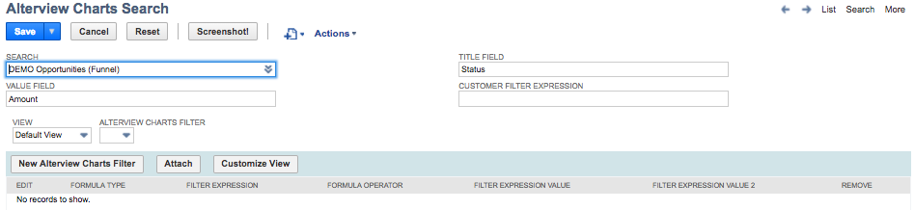

|  |  |
| --- | --- |
| Field | Description |
| Search | The name of the search (make sure the search is public). |
| Value Field | The Custom Label for the column that holds the relevant value for this search. |
| Title Field | The Custom Label for the column that holds the title. |
| Customer Filter Expression | If the chart is going to be used in a customer dashboard or on a tab on the customer record, set the expression that will be used to filtering out the customer.  Example 1:[customermain.internalidnumber,equalto,{id}]  Example 2:[entityid,anyof,{id}]  Example 3:[formulanumeric: {internalid},equalto,{id}]  Where the {id} is the internalid of current customer the {id} is substituted by the application at runtime. |
| Alterview Charts Filter | Only needed when using *Alterview Navigator* to filter the chart (please refer to Additional Filters). |

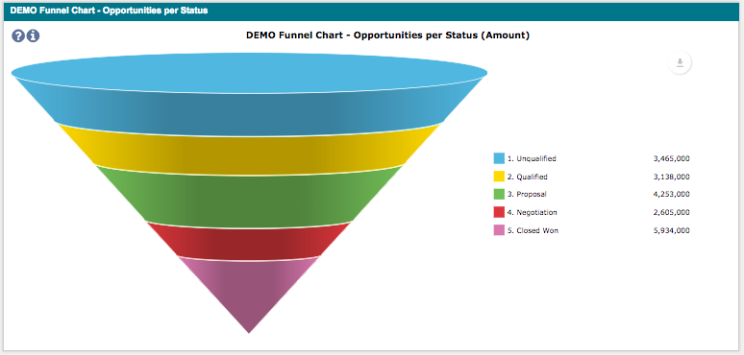

#### Gauge Chart

The Gauge chart is used to compare two values with each other. By coloring the gauge we could also give the user a hint if the value is acceptable or not.



1. **Configure the search**

*Number of searches: 1 or 2*

In order use the gauge chart the saved search/searches needs to contain two value fields, one containing the max value (**reference search**) and one containing the actual value to compare (**compare value search**). The data can be collected from two different searches or from one single search, if both max value and compare value exist in the same search.

There are two options for creating searches for Gauge Charts:

* A Summary Search that produces only one row.
* A Grouped summary search that produces several rows

Make sure the saved searches are public and to include a Custom Label for the fields which will be displayed in the chart. If it's a summary search the Summary label must also be defined.

The *reference search* must include 2 columns:

1. Name (will not be displayed in the chart)
2. Value (the max value for the gauge, will be displayed in the chart)

The *compare search* must include 2 columns:

1. Name (will not be displayed in the chart)
2. Value (the compare value for the gauge, will be displayed in the chart)

If the underlying data is of great importance for the user, a Summary search that produces several rows is the best choice. If the searches produce more than one row, the functionality Search Summary Field Type needs to be used.

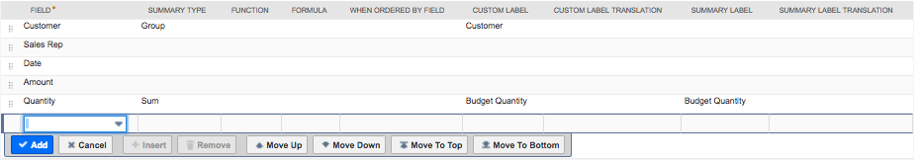

*In this DEMO Budget search: Name = Customer, Value (max) = Budget Quantity*

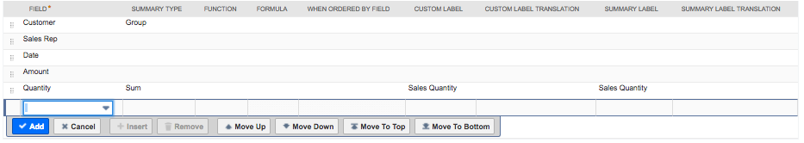

*In this DEMO Budget search: Name = Customer, Value (compare) = Sales Quantity*

1. **Create the chart record**

After the search is created and tested a new Alterview Charts record must be created.

Navigate to Administration 🡪 Alterview Charts Setup 🡪 Charts 🡪 New to create a new Alterview Charts record. Enter information in the fields as described below.

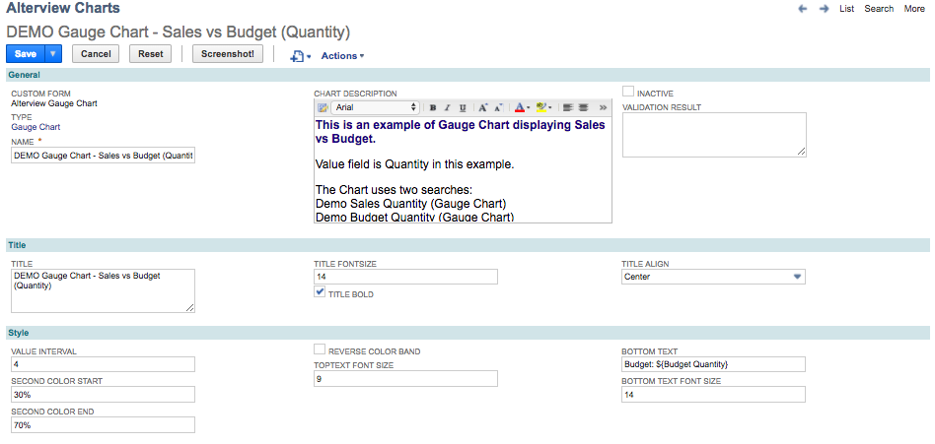

|  |  |
| --- | --- |
| Field | Description |
| Name | The name should be descriptive and give the user a hint of what is displayed in the dashboard portlet. |
| Description | An extra field where you could add extra information about the chart. The description can be accessed from the dashboard portlet by hovering over the “?” icon in the upper left corner of the chart. |
| Title | The chart title will be displayed centered above the graph. When combining Alterview Charts with Alterview Navigator extra info is available (please refer to Chart Title Using Alterview Navigator). |
| Font Size | Font size of chart title in pixels. |
| Title Bold | Mark checkbox to make the chart title bold. |
| Title Align | Select the alignment of the chart title. |
| Value interval | Absolute interval between values shown on gauge. If set to 20 and max value is 195 the gauge will show labels with values in steps of 20 until 200. If left empty or set to zero, the interval is set to auto. |
| Second color start | The value where the gauge band turns yellow. This can be absolute value or percentage value. |
| Second color end | The value where the gauge yellow band change color. This can be absolute value or percentage value. |
| Reverse color band | If set, the color band colors green and red change places on gauge. |
| Top Text Font Size | The size of the text in the center of the gauge. |
| Bottom text | The text at the bottom of the gauge. The text can be a combination of a static text and dynamic values from the search. The syntax for a dynamic value is ${Value Field}.   *Example*:  If the Custom Label for the reference value (195) is "Estimated Work" and the Custom Label for the compare value (167) is "Actual Work":  “Estimated: ${Estimated Work}” will produce “Estimated: 195”  “${Actual Work}(${Estimated Work})” will produce “167(195)” |
| Bottom Text Font Size | The size of the text at the bottom of the gauge. |

1. **Link the search to your chart record**

From the Alterview Chart record, click on the button *New Alterview Chart Serarch* to create a new Alterview Chart Search child record to you chart. Enter information in the fields as described below.

Please note that *Alterview Charts Filter* is only needed when using *Alterview Navigator* to filter the chart.

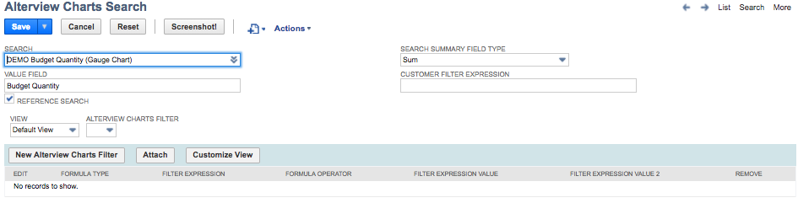

|  |  |
| --- | --- |
| Field | Description |
| Search | The name of the search (make sure the search is public). |
| Value Field | The Custom Label for the column that holds the relevant value for this search. |
| Reference Search | Mark the checkbox if the search is the reference search. |
| Search Summary Field Type | Please refer to Search Summary Field Type |
| Customer Filter Expression | If the chart is going to be used in a customer dashboard or on a tab on the customer record, set the expression that will be used to filtering out the customer.  Example 1:[customermain.internalidnumber,equalto,{id}]  Example 2:[entityid,anyof,{id}]  Example 3:[formulanumeric: {internalid},equalto,{id}]  Where the {id} is the internalid of current customer the {id} is substituted by the application at runtime. |
| Alterview Charts Filter | Only needed when using *Alterview Navigator* to filter the chart (please refer to Additional Filters). |

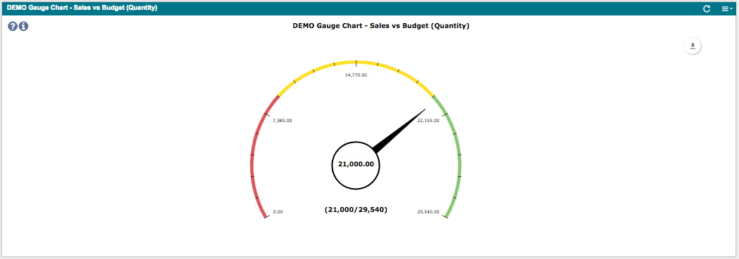

#### Gauge Percentage Chart

The Gauge percentage chart is used to compare two values with each other. By coloring the gauge, we could also give the user a hint if the value is acceptable or not.



1. **Configure the search**

*Number of searches: 1 or 2*

In order use the gauge percentage chart the saved search/searches needs to contain two value fields, one containing the max value (**reference search**) and one containing the actual value to compare (**compare value search**). The data can be collected from two different searches or from one single search, if both max value and compare value exist in the same search.

There are two options for creating searches for Gauge Percentage Charts:

* A Summary Search that produces only one row.
* A Grouped summary search that produces several rows

Make sure the saved searches are public and to include a Custom Label for the fields which will be displayed in the chart. If it's a summary search the Summary label must also be defined.

The *reference search* must include 2 columns:

1. Name (will not be displayed in the chart)
2. Value (the max value for the gauge, will be displayed in the chart)

The *compare search* must include 2 columns:

1. Name (will not be displayed in the chart)
2. Value (the compare value for the gauge, will be displayed in the chart)

If the underlying data is of great importance for the user, a Summary search that produces several rows is the best choice. If the searches produce more than one row, the functionality Search Summary Field Type needs to be used.

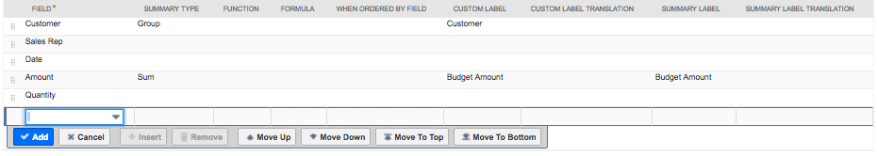

*In this DEMO Budget search: Name = Customer, Value (max) = Budget Amount*

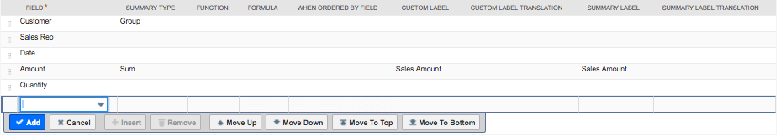  
*In this DEMO Sales search: Name = Customer, Value (max) = Sales Amount*

1. **Create the chart record**

After the search is created and tested a new Alterview Charts record must be created.

Navigate to Administration 🡪 Alterview Charts Setup 🡪 Charts 🡪 New to create a new Alterview Charts record. Enter information in the fields as described below.

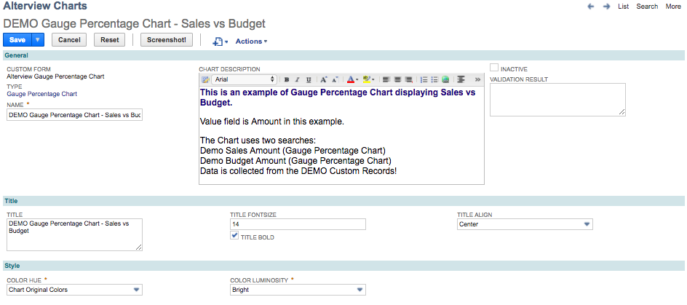

|  |  |
| --- | --- |
| Field | Description |
| Name | The name should be descriptive and give the user a hint of what is displayed in the dashboard portlet. |
| Description | An extra field where you could add extra information about the chart. The description can be accessed from the dashboard portlet by hovering over the “?” icon in the upper left corner of the chart. |
| Title | The chart title will be displayed centered above the graph. When combining Alterview Charts with Alterview Navigator extra info is avaliable (please refer to Chart Title Using Alterview Navigator). |
| Font size | Font size of chart title in pixels. |
| Title Bold | Mark checkbox to make the chart title bold. |
| Title Align | Select the alignment of the chart title. |
| Color Hue | The color hue of the chart. |
| Color Luminosity | The color luminosity of the chart. |

1. **Link the search to your chart record**

From the Alterview Chart record, click on the button *New Alterview Chart Serarch* to create a new Alterview Chart Search child record to you chart. Enter information in the fields as described below.

Please note that *Alterview Charts Filter* is only needed when using *Alterview Navigator* to filter the chart.

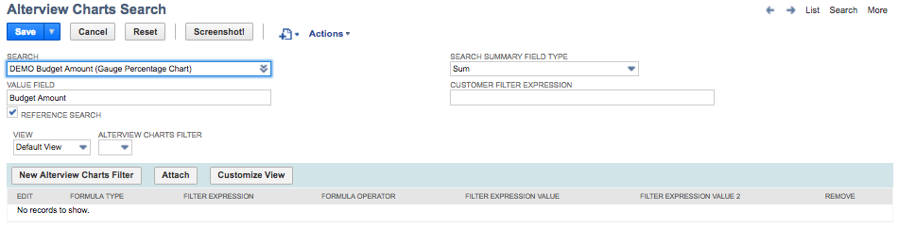

|  |  |
| --- | --- |
| Field | Description |
| Search | The name of the search (make sure the search is public). |
| Value Field | The Custom Label for the column that holds the relevant value for this search. |
| Reference Search | Mark the checkbox if the search is the reference search. |
| Search Summary Field Type | Please refer to Search Summary Field Type |
| Customer Filter Expression | If the chart is going to be used in a customer dashboard or on a tab on the customer record, set the expression that will be used to filtering out the customer.  Example 1:[customermain.internalidnumber,equalto,{id}]  Example 2:[entityid,anyof,{id}]  Example 3:[formulanumeric: {internalid},equalto,{id}]  Where the {id} is the internalid of current customer the {id} is substituted by the application at runtime. |
| Alterview Charts Filter | Only needed when using *Alterview Navigator* to filter the chart (please refer to Additional Filters). |

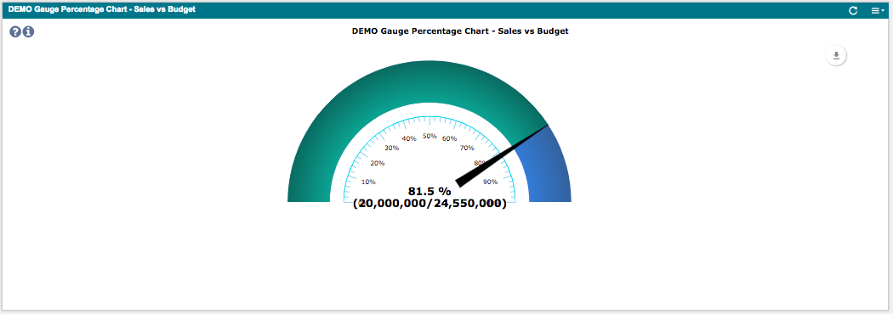

#### Line Chart

The line chart is often used to show trends over time.



1. **Configure the search**

*Number of searches: 1 or more*

To display data in the line chart, at least one saved search is needed, but more likely the chart will display data from several saved searches to compare data over time. The data can be collected from two different searches or from one single search.

When using the line chart it is recommended to also include a **reference search**. The reference search contains all the x-values which should be displayed in the chart.

Make sure the searches are public and to include a Custom Label for the fields which will be displayed in the chart. If it's a summary search the Summary label must also be defined.

The searches must include a minimum of 2 columns:

1. Name (of the item/unit to be displayed in the chart)
2. Value (of the item/unit to be displayed in the chart)

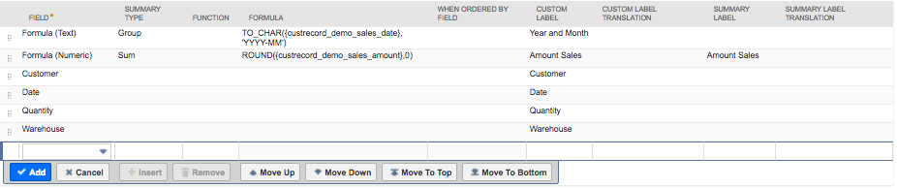

*In this DEMO Sales search: Title = Year and Month, Value = Amount Sales*

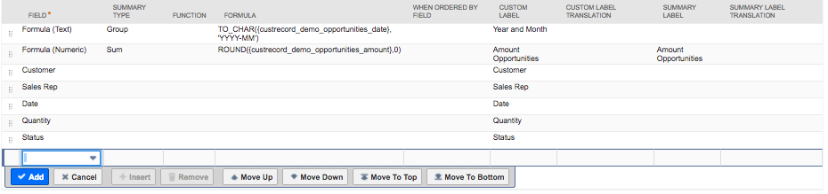

*In this DEMO Opportunities search: Title = Year and Month, Value = Amount Opportunities*

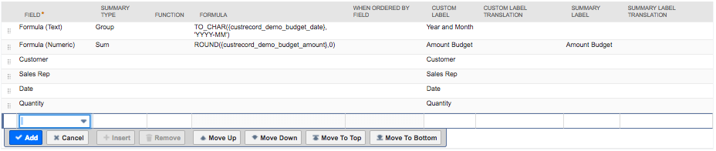

*In this DEMO Budget search: Title = Year and Month, Value = Amount Budget*

When creating a search over different time periods, some periods might be missing (for example if there are no invoices created for a specific period). In this case it is recommended to create a reference searchwhich contains all periods. If the purpose of the reference search is to make sure all x-values are present, the search itself should not be visible in the chart.

The reference search contains the x-values we would like to display in the chart. The other searches compare value searchescontains data for different periods.

1. **Create the chart record**

After the searches are created and tested a new Alterview Charts record must be created.

Navigate to Administration 🡪 Alterview Charts Setup 🡪 Charts 🡪 New to create a new Alterview Charts record. Enter information in the fields as described below.

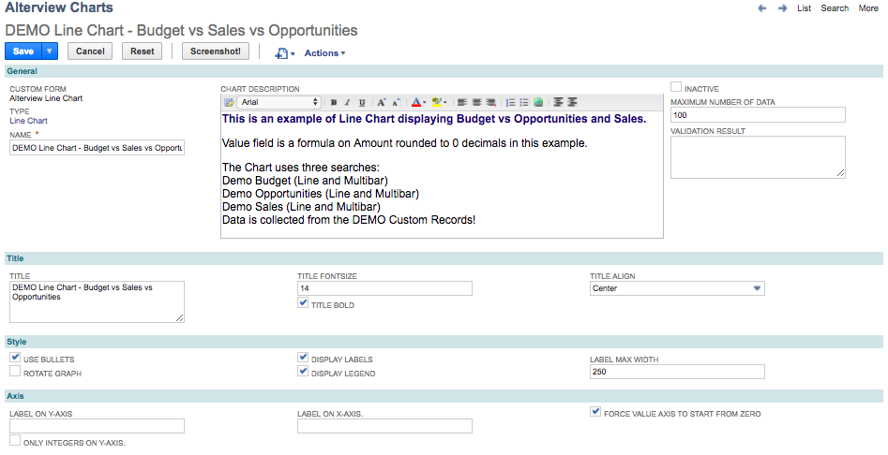

|  |  |
| --- | --- |
| Field | Description |
| Name | The name should be descriptive and give the user a hint of what is displayed in the dashboard portlet. |
| Chart Description | An extra field where you could add extra information about the chart. The description can be accessed from the dashboard portlet by hovering over the “?” icon in the upper left corner of the chart. |
| Maximum number of data | Number of points (x,y) that will be displayed in the chart. If a reference search is defined, that search will be used when finding out how many values to display. |
| Title | The chart title will be displayed centered above the graph. When combining Alterview Charts with Alterview Navigator extra info is avaliable (please refer to Chart Title Using Alterview Navigator). |
| Font size | Font size of Chart Title in pixels. |
| Title Bold | Mark checkbox to make the chart title bold. |
| Title Align | Select the alignment of the chart title. |
| Use bullets | Mark the checkbox to display a bullet for each value point in the chart. When hovering over the bullet, a tooltip will be displayed with following syntax: [value field], [label on y-axis] X:Y |
| Rotate Graph | Rotates the graph 90 degrees clockwise. |
| Display Labels | Mark the checkbox to display the name of the labels below each bar. |
| Display Legend | Mark the checkbox to display the legend for each bar to the right of the chart. |
| Label max width | The width of the labels below the x-axis. |
| Label on Y-axis | A static label which will be centered vertically in the chart. |
| Only integers on Y-axis | Only show integers on Y-axis. |
| Label on X-axis | A static label which will be centered horizontally in the chart. |
| Force value axis to start from zero | Mark the checkbox to force the value axis to start from zero. |

1. **Link the search to your chart record**

From the Alterview Chart record, click on the button *New Alterview Chart Serarch* to create a new Alterview Chart Search child record to you chart. Enter information in the fields as described below. To display several values in one line chart, the values are grouped into the same bar by using the same Title field for each Alterview Charts Search record.

Please note that *Alterview Charts Filter* is only needed when using *Alterview Navigator* to filter the chart.

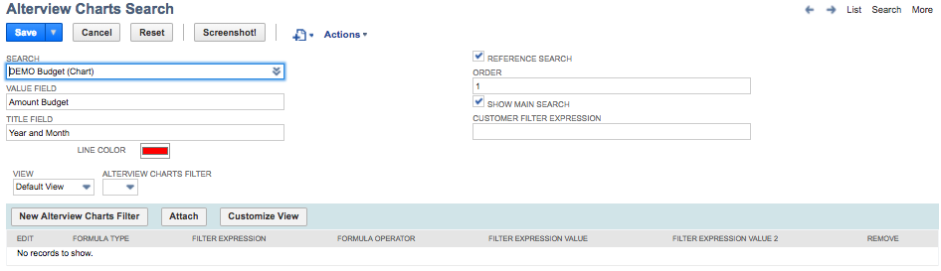

|  |  |
| --- | --- |
| Field | Description |
| Search | The name of the search (make sure the search is public). |
| Value Field | The Custom Label for the column that holds the relevant value for this search. |
| Title Field | The Custom Label for the column that holds the title. |
| Line Color | The color of the line. If set, all Alterview Chart Searches connected to this chart must have a color defined. |
| Reference Search | When a maximum number of data has been set for the chart, and the different searches returns different number of results, one of the searches must be set as reference search to define which results to show and in which order. |
| Order | Controls the order of the legends. |
| Show main search | If both **Reference Search** and **Show main search** is checked, this search will not show up in the chart and only work as a reference for the other searches. |
| Customer Filter Expression | If the chart is going to be used in a customer dashboard or on a tab on the customer record, set the expression that will be used to filtering out the customer.  Example 1:[customermain.internalidnumber,equalto,{id}]  Example 2:[entityid,anyof,{id}]  Example 3:[formulanumeric: {internalid},equalto,{id}]  Where the {id} is the internalid of current customer the {id} is substituted by the application at runtime. |
| Alterview Charts Filter | Only needed when using *Alterview Navigator* to filter the chart (please refer to Additional Filters). |

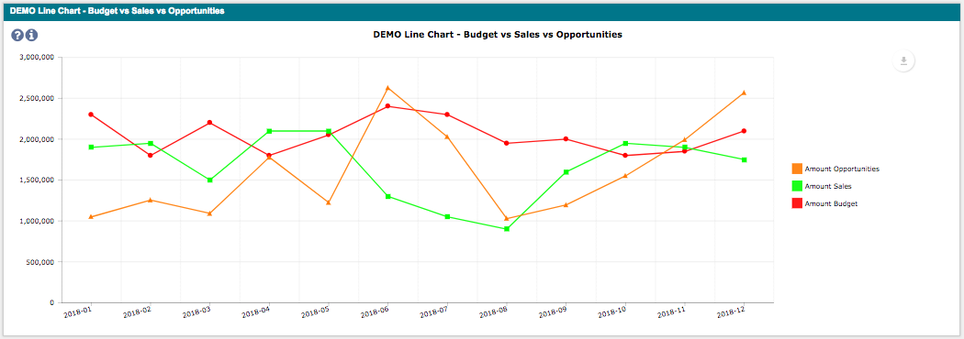

#### Gantt Chart (Beta)

The line chart is often used to show activities over a day based timeline.

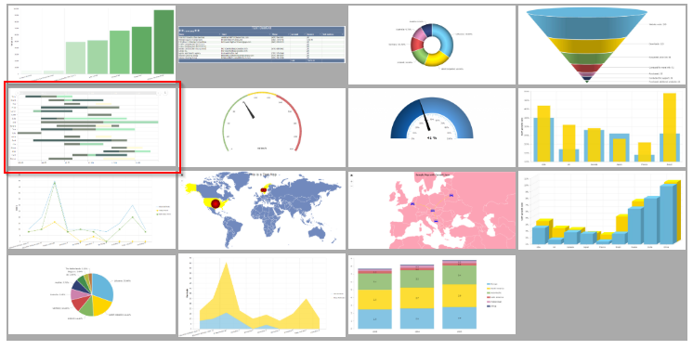

1. **Configure the search**

*Number of searches: 1 or more*

To display data in the gantt chart, at least one saved search is needed, but it is possible to display data from several saved searches.

Make sure the searches are public and to include a Custom Label for the fields which will be displayed in the chart. If it's a summary search the Summary label must also be defined.

It is important that the labels in the search have “H:” in front of the title- and color-field and “L:” in front of the Value, Start- and End Date fields.

The searches must include a minimum of 4 columns:

1. Title (Each unique title will be a single line in the gantt-chart. Preferably label “H:Title”)
2. Value (For each value a box will be added, this is the label for that box. Preferably label “L:Value”)
3. Start Date (The start date for the gantt-box. Preferably label “L:StartDate”)
4. End Date (The end date for the gantt-box. Preferably label “L:EndDate”)

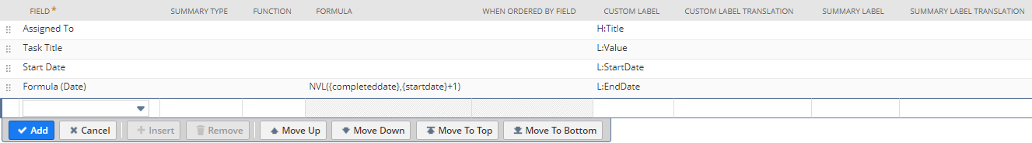

1. **Create the chart record**

After the searches are created and tested a new Alterview Charts record must be created.

Navigate to Administration 🡪 Alterview Charts Setup 🡪 Charts 🡪 New to create a new Alterview Charts record. Enter information in the fields as described below.

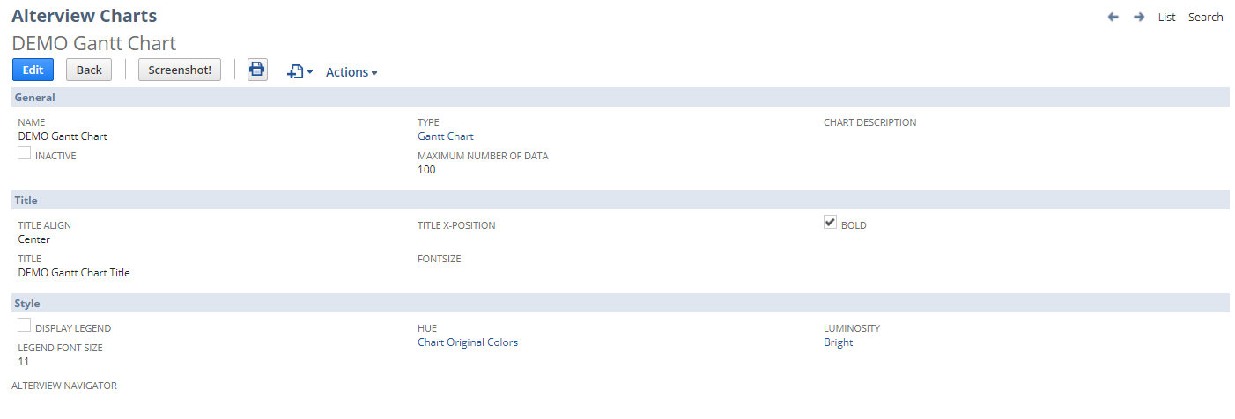

|  |  |
| --- | --- |
| Field | Description |
| Name | The name should be descriptive and give the user a hint of what is displayed in the dashboard portlet. |
| Chart Description | An extra field where you could add extra information about the chart. The description can be accessed from the dashboard portlet by hovering over the “?” icon in the upper left corner of the chart. |
| Maximum number of data | Number of points (x,y) that will be displayed in the chart. If a reference search is defined, that search will be used when finding out how many values to display. |
| Title | The chart title will be displayed centered above the graph. When combining Alterview Charts with Alterview Navigator extra info is avaliable (please refer to Chart Title Using Alterview Navigator). |
| Font size | Font size of Chart Title in pixels. |
| Title Bold | Mark checkbox to make the chart title bold. |
| Title Align | Select the alignment of the chart title. |
| Display Legend | Mark the checkbox to display the legend for each row on the bottom of the chart. |

1. **Link the search to your chart record**

From the Alterview Chart record, click on the button *New Alterview Chart Search* to create a new Alterview Chart Search child record to you chart. Enter information in the fields as described below. To display several values on one row in the gantt chart, the values are grouped into the same row by using the same Title field for each Alterview Charts Search record.

Please note that *Alterview Charts Filter* is only needed when using *Alterview Navigator* to filter the chart.



|  |  |
| --- | --- |
| Field | Description |
| Search | The name of the search (make sure the search is public). |
| Value Field | The Custom Label for the column that holds the relevant value for this search. |
| Title Field | The Custom Label for the column that holds the title. |
| Start Date Field | The Custom Label for the column that holds the start date for this box |
| End Date Field | The Custom Label for the column that holds the end date for this box |
| Gantt color field | This is optional, but you can set the custom label in the search that holds a color-value to color this specific box in a certain color. |
| Order | Controls the order of the legends. |
| Customer Filter Expression | If the chart is going to be used in a customer dashboard or on a tab on the customer record, set the expression that will be used to filtering out the customer.  Example 1:[customermain.internalidnumber,equalto,{id}]  Example 2:[entityid,anyof,{id}]  Example 3:[formulanumeric: {internalid},equalto,{id}]  Where the {id} is the internalid of current customer the {id} is substituted by the application at runtime. |

#### Pie Chart

Pie charts is a good choice when visualizing for example market share per company.



1. **Configure the search**

*Number of searches: 1*

When using the line chart it is recommended to also include a **reference search**. The reference search contains all the x-values which should be displayed in the chart.

Make sure the saved search is public and to include a Custom Label for the fields which will be displayed in the chart. If it's a summary search the Summary label must also be defined.

The search must include a minimum of 2 columns:

1. Name (of the item/unit to be displayed in the chart)
2. Value (of the item/unit to be displayed in the chart

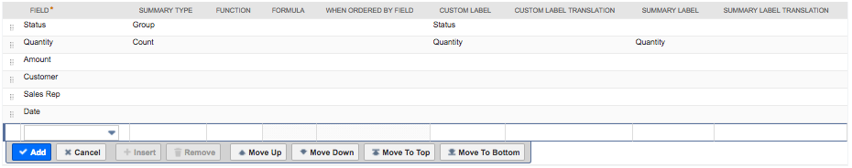

*In this DEMO Opportunity search: Title = Status, Value = Quantity*

1. **Create the chart record**

After the search is created and tested a new Alterview Charts record must be created.

Navigate to Administration 🡪 Alterview Charts Setup 🡪 Charts 🡪 New to create a new Alterview Charts record. Enter information in the fields as described below.

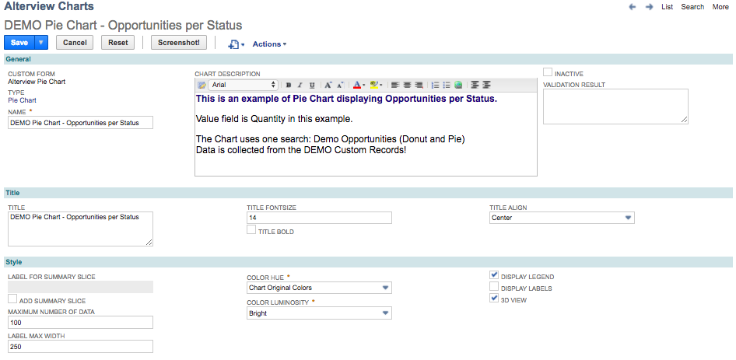

|  |  |
| --- | --- |
| Field | Description |
| Name | The name should be descriptive and give the user a hint of what is displayed in the dashboard portlet. |
| Chart Description | An extra field where you could add extra information about the chart. The description can be accessed from the dashboard portlet by hovering over the “?” icon in the upper left corner of the chart. |
| Title | The chart title will be displayed centered above the graph. When combining Alterview Charts with Alterview Navigator extra info is avaliable (please refer to Chart Title Using Alterview Navigator). |
| Font Size | Font size of Chart Title in pixels. |
| Title Bold | Mark checkbox to make the chart title bold. |
| Title Align | Select the alignment of the chart title. |
| Label for summary slice | The name of the summary slice which holds the aggregated value of the remaining result rows. |
| Add Summary Slice | Mark the checkbox to add a summary slice. When the number of result rows in the saved search exceeds the "Maximum number of data" set in the Alterview Charts record an extra slice will be added, which holds the aggregated value of the remaining result rows. |
| Maximum number of data | Optionally set a maximum number of data to display in the chart. Recommended if your saved search returns too many results. Too much data in a chart will make it cluttered and is not recommended. |
| Label Max width | The label width is the width in pixels for both the legend and the labels. If the width is too small, all labels will be wrapped character per character and not word by word. |
| Color hue | The color hue of the slices. |
| Color Luminosity | The color luminosity of the slices. |
| Display Legend | Mark the checkbox to display the legend for each bar to the right of the chart. |
| Display Labels | Mark the checkbox to display the name of the labels for each slice. |
| 3D-view | Mark the checkbox for 3D-effect. |

1. **Link the search to your chart record**

From the Alterview Chart record, click on the button *New Alterview Chart Serarch* to create a new Alterview Chart Search child record to you chart. Enter information in the fields as described below.

Please note that *Alterview Charts Filter* is only needed when using *Alterview Navigator* to filter the chart.

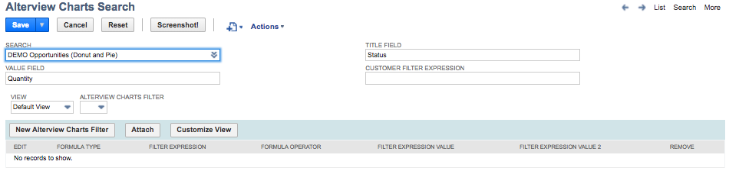

|  |  |
| --- | --- |
| Field | Description |
| Search | The name of the search (make sure the search is public). |
| Value Field | The Custom Label for the column that holds the relevant value for this search. |
| Title Field | The Custom Label name for the column that holds the title. |
| Customer Filter Expression | If the chart is going to be used in a customer dashboard or on a tab on the customer record, set the expression that will be used to filtering out the customer.  Example 1:[customermain.internalidnumber,equalto,{id}]  Example 2:[entityid,anyof,{id}]  Example 3:[formulanumeric: {internalid},equalto,{id}]  Where the {id} is the internalid of current customer the {id} is substituted by the application at runtime. |
| Alterview Charts Filter | Only needed when using *Alterview Navigator* to filter the chart (please refer to Additional Filters). |

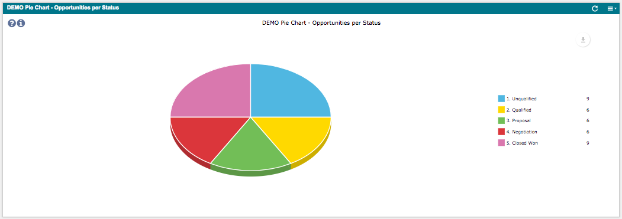

#### Stacked Area Chart

Stacked area charts are used to represent cumulated totals using numbers or percentages over time.



1. **Configure the search**

*Number of searches: 1 or more*

To display data in the stacked area chart, at least one saved search is needed, but more likely the chart will display data from several saved searches to compare data over time. The data can be collected from two different searches or from one single search.

When using the stacked area chart it is possible to also include a **reference search**. The reference search contains all the x-values which should be displayed in the chart.

Make sure the searches are public and to include a Custom Label for the fields which will be displayed in the chart. If it's a summary search the Summary label must also be defined.

The search must include a minimum of 2 columns:

1. Name (of the item/unit to be displayed in the chart)
2. Value (of the item/unit to be displayed in the chart)

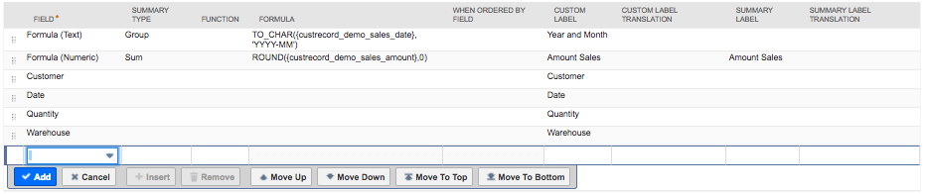

*In this DEMO Sales search: Title = Year and Month, Value = Amount Sales*

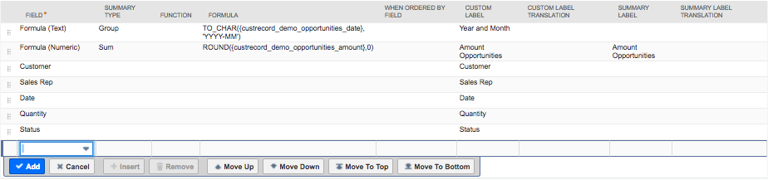

*In this DEMO Opportunities search: Title = Year and Month, Value = Amount Opportunities*

1. **Create the chart record**

After the search is created and tested a new Alterview Charts record must be created.

Navigate to Administration 🡪 Alterview Charts Setup 🡪 Charts 🡪 New to create a new Alterview Charts record. Enter information in the fields as described below.

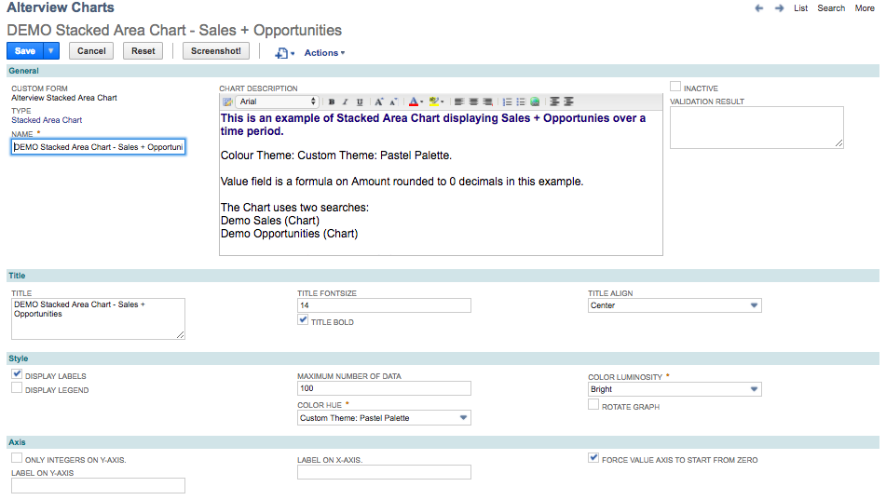

|  |  |
| --- | --- |
| Field Name | Description |
| Name | The name should be descriptive and give the user a hint of what is displayed in the dashboard portlet. |
| Chart Description | An extra field where you could add extra information about the chart. The description can be accessed from the dashboard portlet by hovering over the “?” icon in the upper left corner of the chart. |
| Title | The chart title will be displayed centered above the graph. When combining Alterview Charts with Alterview Navigator extra info is avaliable (please refer to Chart Title Using Alterview Navigator). |
| Title Font Size | Font size of chart title in pixels. |
| Title Bold | Mark checkbox to make the chart title bold. |
| Title Align | Select the alignment of the chart title. |
| Display Labels | Mark the checkbox to display the name of the labels below each value point. |
| Display Legend | Mark the checkbox to display the legend for each bar to the right of the chart. |
| Maximum number of data | Optionally set a maximum number of bars to display in the chart. Recommended if your saved search returns too many results. Too much data in a chart will make it cluttered and is not recommended. |
| Color Hue | The color hue of the chart. |
| Color Luminosity | The color luminosity of the chart. |
| Rotate Graph | Rotates the graph 90 degrees clockwise. |
| Only integers on Y-axis | Only show integers on Y-axis. |
| Label on Y-axis | A static label which will be centered vertically in the chart. |
| Label on X-axis | A static label which will be centered horizontally in the chart. |
| Force value to start from zero | Mark the checkbox to force the value axis to start from zero. |

1. **Link the search to your chart record**

For the Stacked Area chart it is recommended to include at least two *Alterview Chart Search* records. It is possible to use the same saved search for every Alterview Chart Search record or to use different saved searches for each Alterview Chart Search record.

  
*In this example two different saved searches has been used to display data in the chart.*

From the Alterview Chart record, click on the button *New Alterview Chart Serarch* to create a new Alterview Chart Search child record to you chart. Enter information in the fields as described below. To display several values in one stacked area, the values are grouped into the same area/bar by using the same Title field for each Alterview Charts Search record.

Please note that *Alterview Charts Filter* is only needed when using *Alterview Navigator* to filter the chart.

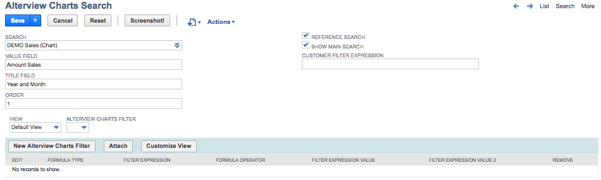

|  |  |
| --- | --- |
| Field | Description |
| Search | The name of the search (make sure the search is public). |
| Value Field | The Custom Label for the column that holds the relevant value for this search. |
| Title Field | The Custom Label for the column that holds the title. |
| Order | Each saved search will be layered on top of each other. The order field will control both legend and the order of how the result is layered. |
| Reference Search | When a maximum number of data has been set for the chart, and the different searches returns different number of results, one of the searches must be set as reference search to define which results to show and in which order. |
| Show main search | Mark the checkbox to display data from the reference search in the chart. If the checkbox is unmarked, the **Reference Search** will not show up in the chart and only work as a reference for the other searches. |
| Customer Filter Expression | If the chart is going to be used in a customer dashboard or on a tab on the customer record, set the expression that will be used to filtering out the customer.  Example 1:[customermain.internalidnumber,equalto,{id}]  Example 2:[entityid,anyof,{id}]  Example 3:[formulanumeric: {internalid},equalto,{id}]  Where the {id} is the internalid of current customer the {id} is substituted by the application at runtime. |
| Alterview Charts Filter | Only needed when using *Alterview Navigator* to filter the chart (please refer to Additional Filters). |

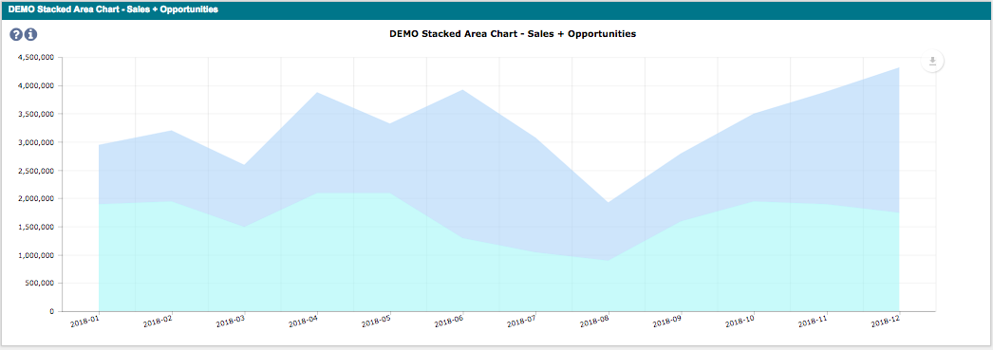

#### Stacked Bar Chart

Stacked Bar Chart are used to show how a larger category is divided into smaller categories and what the relationship of each part has on the total amount.



1. **Configure the search**

*Number of searches: 1 or more*

To display data in the stacked bar chart, at least one saved search is needed, but more likely the chart will display data from several saved searches to compare data. The data can be collected from two different searches or from one single search.

When using the stacked bar chart it is possible to also include a **reference search**. The reference search contains all the x-values which should be displayed in the chart.

Make sure the searches are public and to include a Custom Label for the fields which will be displayed in the chart. If it's a summary search the Summary label must also be defined.

The search must include a minimum of 2 columns:

1. Name (of the item/unit to be displayed in the chart)
2. Value (of the item/unit to be displayed in the chart)

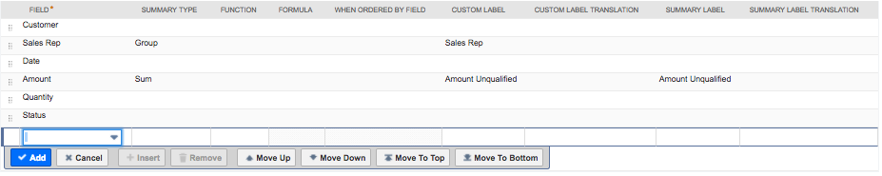

*In this DEMO Opportunities search: Title = Sales Rep, Value = Amount Unqualified*

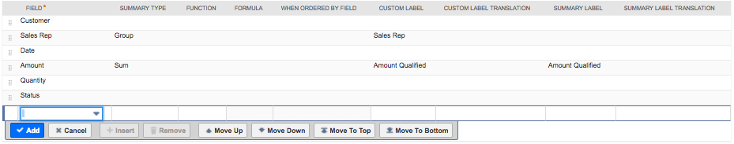

*In this DEMO Opportunities search: Title = Sales Rep, Value = Amount Qualified*

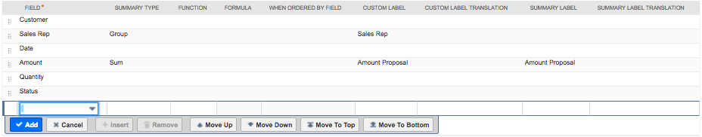

*In this DEMO Opportunities search: Title = Sales Rep, Value = Amount Proposal*

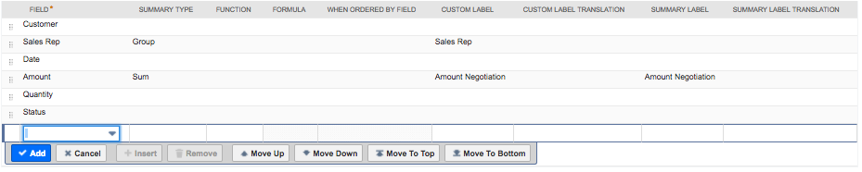

*In this DEMO Opportunities search: Title = Sales Rep, Value = Amount Negotiation*

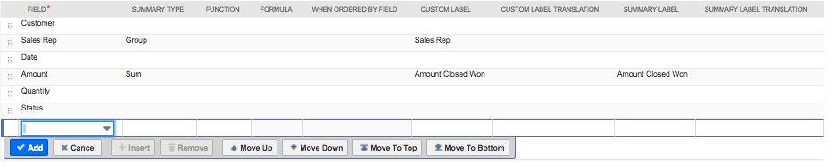  
*In this DEMO Opportunities search: Title = Sales Rep, Value = Amount Closed Won*

1. **Create the chart record**

After the search is created and tested a new Alterview Charts record must be created.

Navigate to Administration 🡪 Alterview Charts Setup 🡪 Charts 🡪 New to create a new Alterview Charts record. Enter information in the fields as described below.

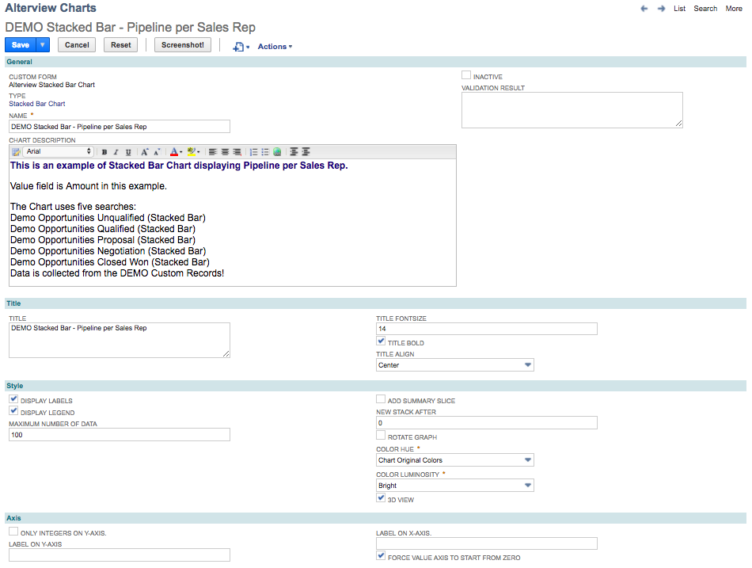

|  |  |
| --- | --- |
| Field Name | Description |
| Name | The name should be descriptive and give the user a hint of what is displayed in the dashboard portlet. |
| Chart Description | An extra field where you could add extra information about the chart. The description can be accessed from the dashboard portlet by hovering over the “?” icon in the upper left corner of the chart. |
| Title | The chart title will be displayed centered above the graph. When combining Alterview Charts with Alterview Navigator extra info is avaliable (please refer to Chart Title Using Alterview Navigator). |
| Title Font Size | Font size of Chart Title in pixels. |
| Title Bold | Mark checkbox to make the chart title bold. |
| Title Align | Select the alignment of the chart title. |
| Display Labels | Mark the checkbox to display the name of the labels below each value point. |
| Display Legend | Mark the checkbox to display the legend for each bar to the right of the chart. |
| Maximum number of data | Optionally set a maximum number of bars to display in the chart. Recommended if your saved search returns too many results. Too much data in a chart will make it cluttered and is not recommended. |
| Add Summary Slice | Mark the checkbox to add a summary bar. When the number of result rows in the saved search exceeds the "Maximum number of data" set in the Alterview Charts record an extra bar will be added, which holds the aggregated value of the remaining result rows. |
| New Stack after | Create new stack after x number of bars. With this feature it is possible to control if the stack should be cumulative or side by side.  New Stack = 0 New Stack=1 |
| Rotate graph | Rotates the graph 90 degrees clockwise. |
| Color Hue | The color hue of the chart. |
| Color Luminosity | The color luminosity of the chart. |
| 3D view | Mark the checkbox for 3D-effect. |
| Only integers on Y-axis | Only show integers on Y-axis. |
| Label on Y-axis | A static label which will be centered vertically in the chart. |
| Label on X-axis | A static label which will be centered horizontally in the chart. |
| Force value to start from zero | Mark the checkbox to force the value axis to start from zero. |

1. **Link the search to your chart record**

For the Stacked Bar chart it is recommended to include at least two *Alterview Chart Search* records. It is possible to use the same saved search for every Alterview Chart Search record or to use different saved searches for each Alterview Chart Search record.

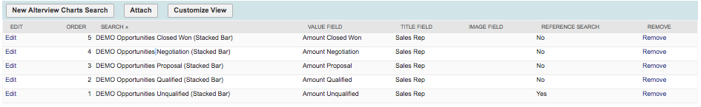  
*In this example five saved search has been used to display data in the chart.*

From the Alterview Chart record, click on the button *New Alterview Chart Serarch* to create a new Alterview Chart Search child record to you chart. Enter information in the fields as described below. To display several values in one stacked bar, the values are grouped into the same bar by using the same Title field for each Alterview Charts Search record.

Please note that *Alterview Charts Filter* is only needed when using *Alterview Navigator* to filter the chart.

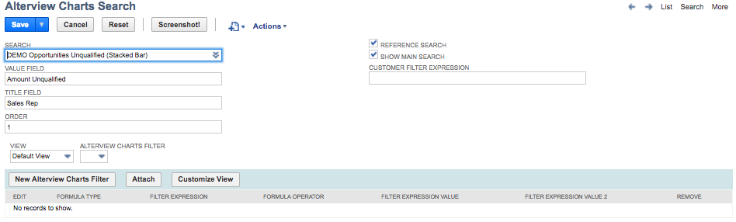

|  |  |
| --- | --- |
| Field | Description |
| Search | The name of the search (make sure the search is public). |
| Value Field | The Custom Label name for the column that holds the relevant value for this search |
| Title Field | The Custom Label for the column that holds the relevant value for this search. |
| Order | The Order field controls the layout of the legend. |
| Reference Search | When a maximum number of data has been set for the chart, and the different searches returns different number of results, one of the searches must be set as reference search to define which results to show and in which order. |
| Show main search | Mark the checkbox to display data from the reference search in the chart. If the checkbox is unmarked, the **Reference Search** will not show up in the chart and only work as a reference for the other searches. |
| Customer Filter Expression | If the chart is going to be used in a customer dashboard or on a tab on the customer record, set the expression that will be used to filtering out the customer.  Example 1:[customermain.internalidnumber,equalto,{id}]  Example 2:[entityid,anyof,{id}]  Example 3:[formulanumeric: {internalid},equalto,{id}]  Where the {id} is the internalid of current customer the {id} is substituted by the application at runtime. |
| Alterview Charts Filter | Only needed when using *Alterview Navigator* to filter the chart (please refer to Additional Filters). |

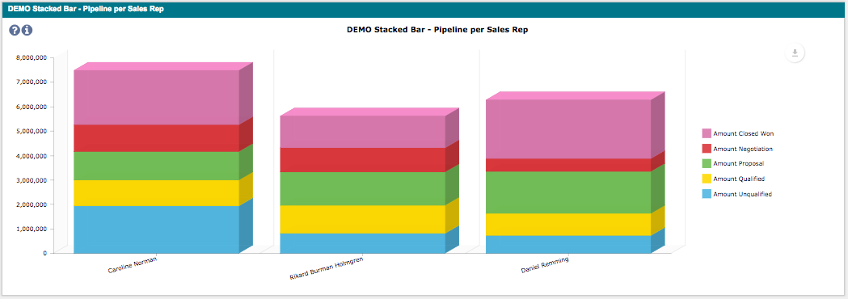

#### Data Grid Chart

The Data Grid is a chart that makes it possible to combine several searches and present the result as a list. The common link between the searches is a key value that the grid uses to match rows from several searches. One search acts as a main search and contains most of the columns that is visible. It is also possible to display search results from only one search.



1. **Configure the search**

*Number of searches: 1 or more*

To display data in the data grid, at least one saved search is needed, but more likely the chart will display data from several saved searches to combine data from several sources. One of the saved searches will act as the main search and defines the result rows to be displayed in the data grid.

Make sure the searches are public and to include a Custom Label for the result fields. If it's a summary search the Summary label must also be defined.

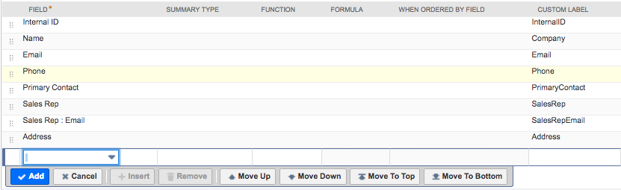  
*In this DEMO Customer search: The main search contains eight result fields with Custom Labels*

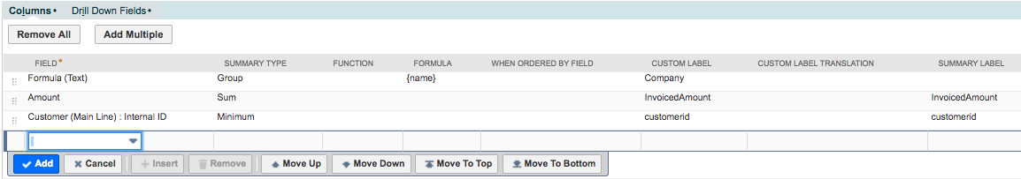

*In this DEMO Transaction search: The second search contains the sum of invoiced amount per customer*

1. **Create the chart record**

After the search is created and tested a new Alterview Charts record must be created.

Navigate to Administration 🡪 Alterview Charts Setup 🡪 Charts 🡪 New to create a new Alterview Charts record. Enter information in the fields as described below. The first image explains the different parts of the data grid.

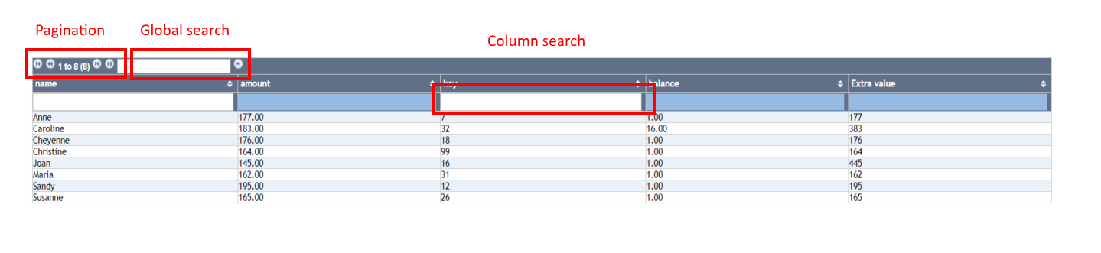

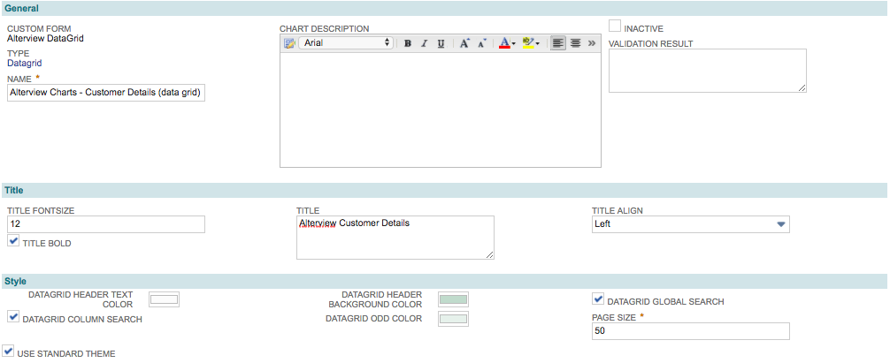

12

11

10

9

8

7

6

5

4

3

2

1

|  |  |  |
| --- | --- | --- |
|  | Field | Description |
| 1 | Name | The name should be descriptive and give the user a hint of what is displayed in the dashboard portlet. |
| 2 | Title font size | Font size of Chart Title in pixels. |
| 3 | Title bold | Mark the checkbox to make the Chart Title bold. |
| 4 | Title | The chart title which will be displayed in the header of the table. |
| 5 | Title align | The horizontal alignment of the title. |
| 6 | Data grid header text color | Select the color of the data grid header text. |
| 7 | Data grid column search | Mark the checkbox to enable a search feature for each column that is searchable. Set the focus on appropriate column, type some text and press enter. |
| 8 | Use standard theme | Mark the checkbox to make the color theme of the data grid match the selected NetSuite color theme for the current user. |
| 9 | Data grid header background color | Manually select the color of the data grid. |
| 10 | Data grid odd color | Manually select the hover color for odd rows. |
| 11 | Data grid global search | Mark the checkbox to make the data grid searchable. |
| 12 | Page size | The number of rows on each page in the data grid. |

1. **Link the searches to your chart record**

For the Data Grid it is common to include at least two *Alterview Chart Search* records. One of the searches is selected to be the main search and contains most information to be displayed in the data grid. Additional searches can be added to include data from several sources In the data grid.

  
*In this example two saved searches have been selected to display data in the chart.*

From the Alterview Chart record, click on the button *New Alterview Chart Serarch* to create a new Alterview Chart Search child record to you chart, starting with one of the additional searches (not the main search).

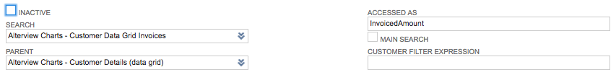

Select the relevant saved search and enter a descriptive name for the search in the field *Accessed As* (with no spaces) and click *Save*.

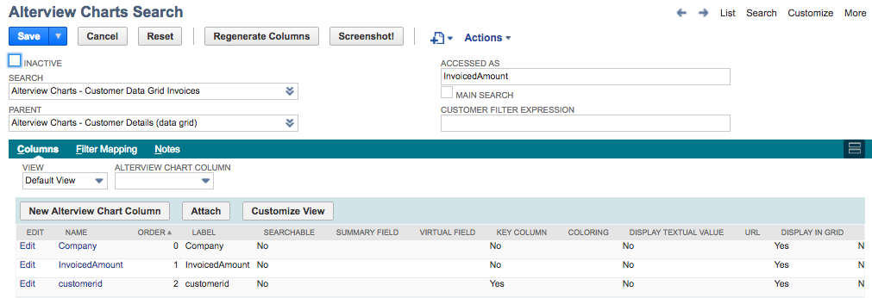  
  
Click on the button *Regenerate Columns* and the chart application will create a list of columns based on the search. Make sure one of the columns is marked as Key Column (this column will connect the searches together). If one of the result columns from the saved search is named ‘key' the application will automatically suggest that column to be the key column.

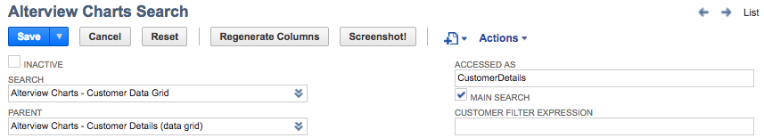

Repeat the steps for the main search, but this time mark the checkbox *Main search*.

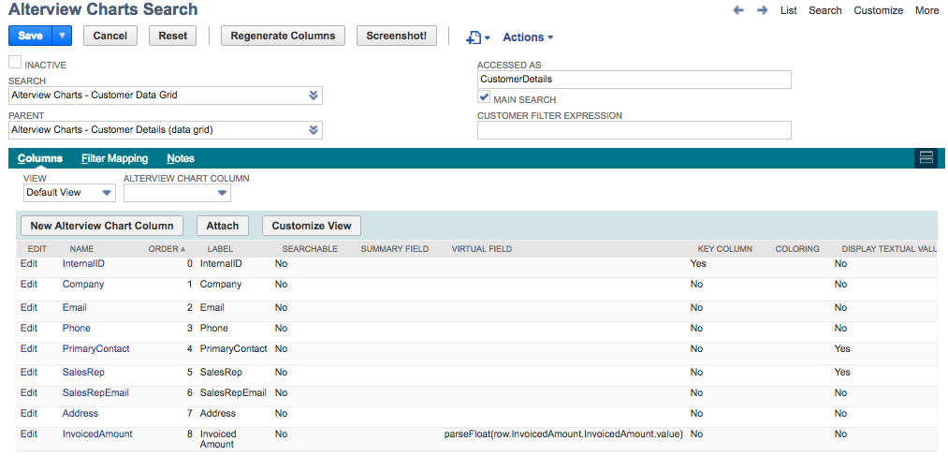

Click on the button *Regenerate Columns* and the chart application will create a list of columns based on the search. Make sure the appropriate column is marked as Key Column (this column will connect the searches together).

1. **Include columns from the additional searches (Virtual columns)**

From the main search record, click on *New Alterview Chart Column* to create an additional column to display in the data grid.

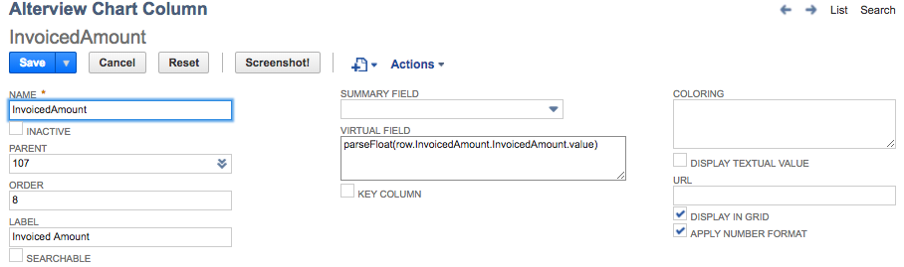

Give the column a name and order, as well as a label (to be displayed in the data grid column). Next, it’s time to set the content of the virtual field.

The virtual field is the most complicated field in the data grid and should be seen as a javascript function to be evaluated for each row. The syntax for accessing a value from any of the additional searches linked to the data grid is:

*row.[accessedas].[column name].[text/value]*

***accessedas*** = The field "Accessed As" from selected Alterview Search Record (additional search)

***column name*** = The name of the Alterview Chart Column for the selected column.

***text/value*** = In most cases the *value* from a particular field is selected to be displayed.

However, List/Record fields always have two values, a textual value (text) and a id (value). Therefore, it is possible to select which of the two to display in the data grid, the *text* or the *value*. Again, the *value* is the most common choice.



In this example, the value from the row *InvoicedAmount* in the additional search has been selected to be displayed in the data grid. The additional search is accessed as *InvoicedAmount,* giving the syntax: *row.InvoicedAmount.InvoicedAmount.value.*

Common functions to be used in the virtual field include:

*parseFloat* – convert string to a float number

*parseInt* – convert string to integer

*number.toFixed(n)* – convert a number to a string with n decimals

Any type of javascript function can be used as long as the result is one value.

1. **Make the row clickable**

As stated before, List/Record fields (for example the name field of a transaction) always have two values, a textual value (text) and an internalid id (value). Therefore, it is possible to make a List/Record field clickable in the data grid.

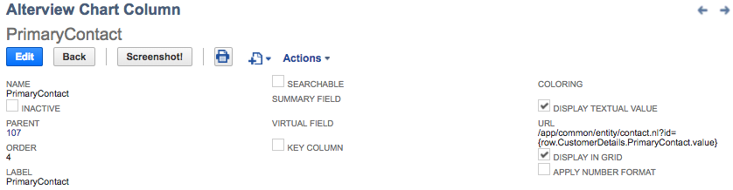

Check the field "Display Textual value" if you would like to show the textual value for a List/Record field in the data grid (when regenerating columns, the data grid will always set the checkbox true for all List/Record fields).

In the *URL* field, enter the URL for the relevant List/Record (navigate to a record of that type in NetSuite and copy the part of the URL from */app/common….*) in this case the Contact record .

To make the URL dynamic, exchange the id number in the URL to a value from any row by the syntax *{row.[accessed as].[name of field].value}*

In this case we would like to dynamically enter the internal id (value) for the Primary Contact from the main search accessed as "CustomerDetails" with its value, so the complete URL will be:

*/app/common/entity/ccontact.nl?id={row.CustomerDetails.PrimaryContact.value}*



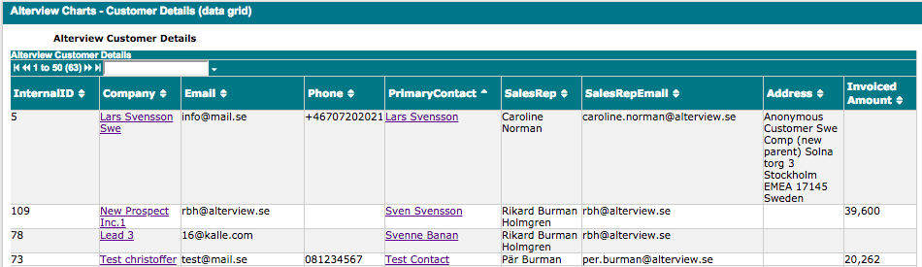

The Primary Contact as well as the Company name is clickable and will redirect the user to the relevant record. The Invoiced Amount is collected from the additional search and displayed in the data grid via a virtual column.

#### Map with Bubbles

The Map with bubbles chart makes it possible to combine several searches and present the data on a map, for example sales per customer. The size of the bubbles can be set to reflect the data. It is also possible to display search results from only one search.



1. **Configure the search**

*Number of searches: 1 or more*

To display data in the map with bubbles chart, at least one saved search is needed. To display data from multiple sources on the map, several saved searches can be used.

Make sure the searches are public and to include a Custom Label for the result fields. If it's a summary search the Summary label must also be defined.

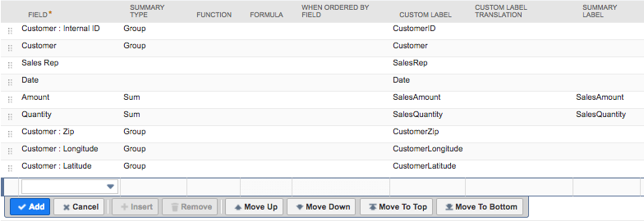

*In this DEMO Sales search: The search contains longitude, latitude and sales amount per customer*

1. **Create the chart record**

After the search is created and tested a new Alterview Charts record must be created.

Navigate to Administration 🡪 Alterview Charts Setup 🡪 Charts 🡪 New to create a new Alterview Charts record. Enter information in the fields as described below.

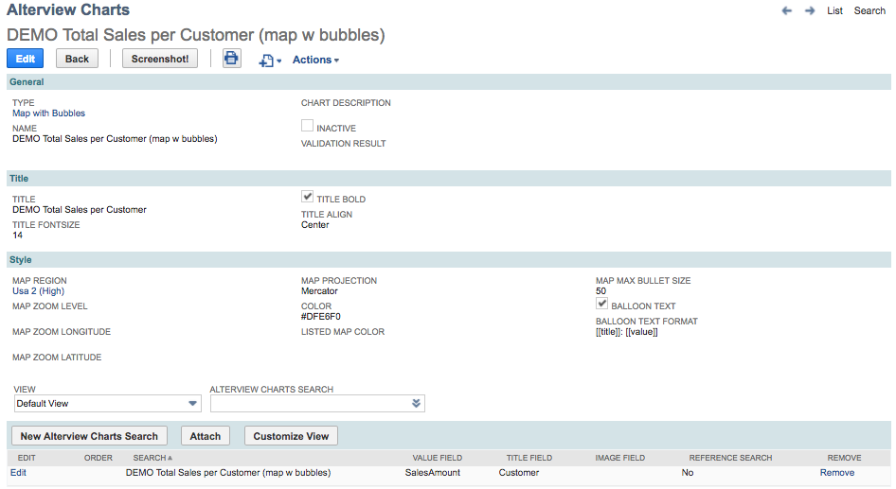

|  |  |
| --- | --- |
| Field | Description |
| Name | The name should be descriptive and give the user a hint of what is displayed in the portlet |
| Chart Description | An extra field where you could add extra information about the chart. The description can be accessed from the dashboard portlet by hovering over the “?” icon in the upper left corner of the chart. |
| Title | The chart title will be displayed above the chart. When combining Alterview Charts with Alterview Navigator extra info is available (please refer to Chart Title Using Alterview Navigator). |
| Title Font size | Font size of chart title in pixels. |
| Title Bold | Mark the checkbox to make the chart title bold. |
| Title Align | Select the alignment of the chart title. |
| Map Region | Select the background map area from the list provided. |
| Map Zoom Level | Zoom level for the background map, select a value from 1 to 10 (optional). |
| Map Zoom Longitude | The background map will be centered on this longitude (optional). |
| Map Zoom Latitude | The background map will be centered on this latitude (optional). |
| Map Projection | Select the appearance of the map from the list provided. |
| Color | The color of the background map. |
| Listed Map Color | Select a color to highlight the countries which appears in the search (the search must include a field for country code). |
| Map Max Bullet Size | Defines the max size of the bubble on the map, select a value from 3 to 100. |
| Balloon Text | Mark the checkbox to display label text when hovering over bubble. |
| Balloon Text Format | Enter the text format for the label, including dynamic text values (ex. [[title]]). |

1. **Link the searches to the chart**

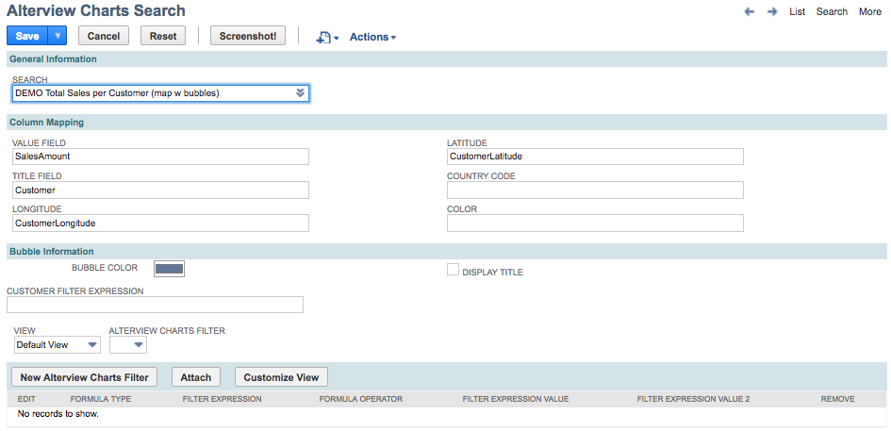

|  |  |
| --- | --- |
| Field | Description |
| Search | The name of the search (make sure the search is public). |
| Value Field | The Custom Label name for the column that holds the relevant value data in the search. |
| Title Field | The Custom Label name for the column that holds the relevant title data in the search. |
| Longitude | The Custom Label name for the column that holds the relevant longitude data for the bubble in the search. |
| Latitude | The Custom Label name for the column that holds the relevant latitude data for the bubble in the search. |
| Country Code | The Custom Label name for the column that holds the relevant country code data for this search. |
| Color | The custom Label name for the column that holds the relevant color for the bubble in the search. |
| Bubble Color | Define the color of the bubbles, if not defined via the saved search. |
| Display Title | Mark checkbox to display chart title. |
| Customer Filter Expression | If the chart is going to be used in a customer dashboard or on a tab on the customer record, set the expression that will be used to filtering out the customer.  Example 1:[customermain.internalidnumber,equalto,{id}]  Example 2:[entityid,anyof,{id}]  Example 3:[formulanumeric: {internalid},equalto,{id}]  Where the {id} is the internalid of current customer the {id} is substituted by the application at runtime. |
| Alterview Charts Filter | Only needed when using *Alterview Navigator* to filter the chart (please refer to Additional Filters ). |

#### Map with Curved Lines

The Map with curved lines chart makes it possible to combine several searches and present the data on a map, for example sales amount from warehouse to customer. The lines on the map chart can be set to reflect the data. It is also possible to display search results from only one search.



1. **Configure the search**

*Number of searches: 1 or more*

To display data in the map with curved lines chart, at least one saved search is needed, but more likely several saved searches are defined to display data from multiple sources on the map, including start and end points.

Make sure the searches are public and to include a Custom Label for the result fields. If it's a summary search the Summary label must also be defined.

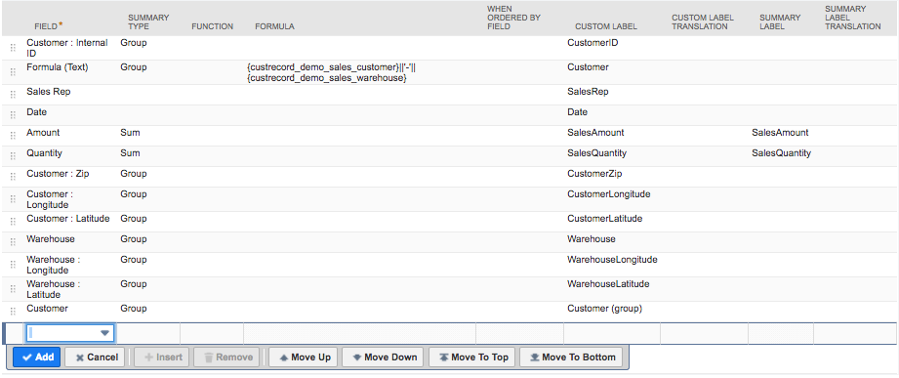

*In this DEMO Sales search: The search contains longitude, latitude for start and end point as well as sales amount per customer. The search include all data needed to display a line on the map.*

1. **Create the chart record**

After the searches are created and tested a new Alterview Charts record must be created.

Navigate to Administration 🡪 Alterview Charts Setup 🡪 Charts 🡪 New to create a new Alterview Charts record. Enter information in the fields as described below.

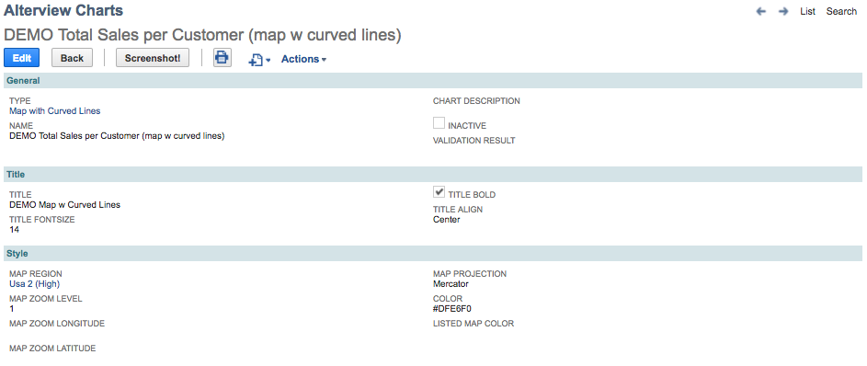

|  |  |
| --- | --- |
| Field | Description |
| Name | The name should be descriptive and give the user a hint of what is displayed in the portlet |
| Chart Description | An extra field where you could add extra information about the chart. The description can be accessed from the dashboard portlet by hovering over the “?” icon in the upper left corner of the chart. |
| Title | The chart title will be displayed above the chart. When combining Alterview Charts with Alterview Navigator extra info is available (please refer to Chart Title Using Alterview Navigator). |
| Title Font size | Font size of chart title in pixels. |
| Title Bold | Mark the checkbox to make the chart title bold. |
| Title Align | Select the alignment of the chart title. |
| Map Region | Select the background map area from the list provided. |
| Map Zoom Level | Zoom level for the background map, select a value from 1 to 10 (optional). |
| Map Zoom Longitude | The background map will be centered on this longitude (optional). |
| Map Zoom Latitude | The background map will be centered on this latitude (optional). |
| Map Projection | Select the appearance of the map from the list provided. |
| Color | The color of the background map. |
| Listed Map Color | Select a color to highlight the countries which appears in the search (the search must include a field for country code). |

1. **Link the searches to the chart**

When using the Map with curved lines chart the search can be of two types, either to display lines on the map (“Is Line Search”) or to display start/end points on the map.

At least one search much be defined to display the lines on the map. For each line search the *Alterview Charts Search* record is marked as “Is Line Search”.

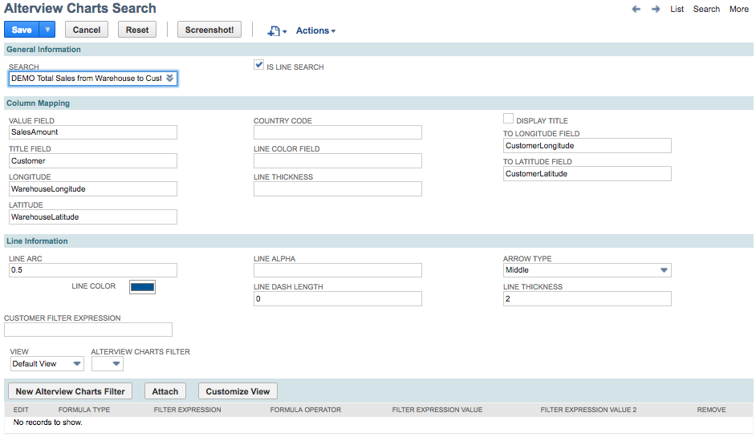

|  |  |
| --- | --- |
| Field | Description |
| Search | The name of the search (make sure the search is public). |
| Is Line Search | Mark the checkbox if the search holds the data for the lines on the map. |
| Value Field | The Custom Label name for the column that holds the relevant value data in the search. |
| Title Field | The Custom Label name for the column that holds the relevant title data in the search. |
| Longitude | The Custom Label name for the column that holds the relevant longitude data for the start point in the search. |
| Latitude | The Custom Label name for the column that holds the relevant latitude data for the start in the search. |
| Country Code | The Custom Label name for the column that holds the relevant country code data in the search. |
| Line Color Field | The custom Label name for the column that holds the relevant color data for the line in the search. |
| Line Thickness | The custom Label name for the column that holds the relevant thickness in pixels for the line in the search. The line thickness can also be set to represent data by using a formula field (a thicker line could for example represent a higher amount or quantity). |
| Display Title | Mark checkbox to display chart title. |
| To Longitude Field | The Custom Label name for the column that holds the relevant longitude data for the end point in the search. |
| To Latitude Field | The Custom Label name for the column that holds the relevant latitude data for the end in the search. |
| Line Arc | Enter a value between -1 to 1 to curve the line. |
| Line Color | Define the color of the line, if not defined via the saved search. |
| Line Alpha | Define the opacity of the line between 0-1. |
| Line Dash Length | Enter the line dash length (0 means the line is not dashed). |
| Arrow Type | Select the position of the arrow. |
| Line Thickness | Set the line thickness in pixels, if not defined via the saved search. |
| Customer Filter Expression | If the chart is going to be used in a customer dashboard or on a tab on the customer record, set the expression that will be used to filtering out the customer.  Example 1:[customermain.internalidnumber,equalto,{id}]  Example 2:[entityid,anyof,{id}]  Example 3:[formulanumeric: {internalid},equalto,{id}]  Where the {id} is the internalid of current customer the {id} is substituted by the application at runtime. |
| Alterview Charts Filter | Only needed when using *Alterview Navigator* to filter the chart (please refer to Additional Filters ). |

To add icons for start or end points of the lines on the map, add another *Alterview Charts Search* record, where the checkbox “Is Line Search” is unmarked.

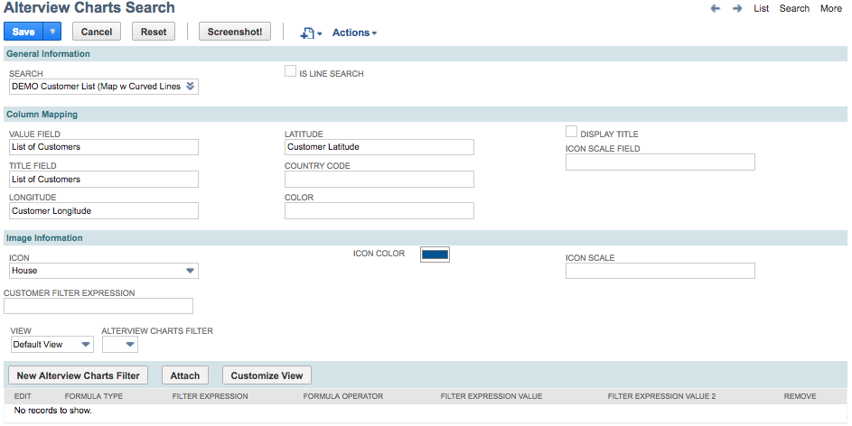

|  |  |
| --- | --- |
| Field | Description |
| Search | The name of the search (make sure the search is public). |
| Is Line Search | Unmark checkbox when the search should mark start or end point on the map (will not create a line on the map). |
| Value Field | The Custom Label name for the column that holds the relevant value data in the search. |
| Title Field | The Custom Label name for the column that holds the relevant title data in the search. |
| Longitude | The Custom Label name for the column that holds the relevant longitude data for the start or end point in the search. |
| Latitude | The Custom Label name for the column that holds the relevant latitude data for the start or end in the search. |
| Country Code | The Custom Label name for the column that holds the relevant country code data in the search. |
| Color | The custom Label name for the column that holds the relevant color for the start/end point icon in the search. |
| Display Title | Mark checkbox to display chart title. |
| Icon Scale Field | The custom Label name for the column that holds the relevant size in pixels for the start or end point icon in the search. The icon size can also be set to represent data by using a formula field (a larger icon could for example represent a higher amount or quantity). |
| Icon | Select icon to display on the map, indicating start or end point. |
| Icon Color | Define the color of the icon, if not defined via the saved search. |
| Icon Scale | Set the size of the start/end point icon in pixels, if not defined via the saved search. |
| Customer Filter Expression | If the chart is going to be used in a customer dashboard or on a tab on the customer record, set the expression that will be used to filtering out the customer.  Example 1:[customermain.internalidnumber,equalto,{id}]  Example 2:[entityid,anyof,{id}]  Example 3:[formulanumeric: {internalid},equalto,{id}]  Where the {id} is the internalid of current customer the {id} is substituted by the application at runtime. |
| Alterview Charts Filter | Only needed when using *Alterview Navigator* to filter the chart (please refer to Additional Filters ). |

# Move to Production

Moving a chart to production consists of three simple steps – Create a Alterview Chart User record for your selected users, add a custom portlet to your dashboard and select which chart(s) to display in the portlet.

*Please note a full access user is required to use Alterview Charts.*

1. **Create a Alterview Chart User record**   
   Navigate to Administration 🡪 Alterview Chart Users to create a Alterview Chart User record for the selected user. A Alterview Chart User record is required for all users who will use Alterview Charts.   
   
2. **Dashboard Custom Portlet**  
   Add a Custom Portlet to your selected dashboard.

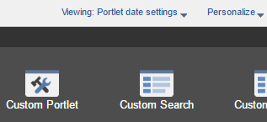

1. **Setup & Edit to select chart**  
   Set up the custom portlet and select *Alterview Chart* in the *Source* field and save.  
   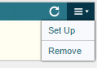 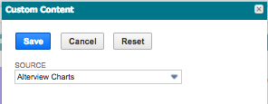   
     
   Go back to the menu in the top right corner to edit the portlet and select which chart to display in the *Alterview Chart View* field and save.  
     
   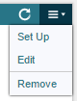 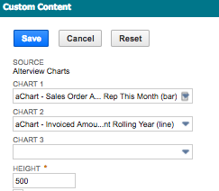  
     
   The selected chart(s) will display in the custom portlet.